# Section 1 – First steps

## High-level overview of Web Development

Static website 🡪 Upon request to the server, the website assets are sent to browser as is

Dynamic website 🡪 Upon request to the server, the backend will assemble the website’s assets and then send to the browser

# Section 2 – HTML Fundamentals

## Structure of HTML document

<!DOCTYPE html> <=== Declare that this document is using HTML

<html> <=== A HTML element to contain all the stuff the HTML doc should have

<head></head>

<body></body>

</html>

## Text elements

|  |  |
| --- | --- |
| **<h1> to <h6>** | Helps to break up text content into sections  Has head from size h1 to h6 (Descending size)  Good practice to have only 1x h1 heading |
| **<p>** | Paragraph of text |
| **<b> OR <strong>** | b: bolding text content (OLD WAY OF BOLDING)  **strong: same as b (NEW WAY, makes more semantic sense)** |
| **<i> OR <em>** | i: italicise text content (OLD WAY)  **em: same as i (NEW WAY, makes more sematic sense)** |
| **<ol>** | Ordered list |
| **<ul>** | Unordered list |
| **<li>** | List item |

## Semantic tags

|  |  |
| --- | --- |
| **<header>** | Contains introductory content for a page (e.g., a banner), or a section of a page. |
| **<nav>** | Contains navigation content, such as a website navigation menu. |
| **<main>** | Contains the main content of the web page. |
| **<section>** | Contains a section of the page’s content |
| **<article>** | Represents a self-contained composition in a document, page, application, or site, which is intended to be independently distributable or reusable |
| **<aside>** | Contains content that is tangentially related to the main content of the page (often this is presented in a sidebar). |
| **<footer>** | Contains the footer of a page, or of a section of a page. Typically, the footer contains information about the content, such as the author and a copyright statement. |

## Semantic HTML

A way of writing HTML whereby each HTML element is writing with the appropriate tag with a proper meaning. This allows clear communication of each element’s meaning to the developer, browser, and users.

* Improve accessibility as text to speech programs make use of the HTML tags to recognize contents

# Section 3 – CSS Fundamentals

## CSS Rule

Many of these can be within 1 .css file

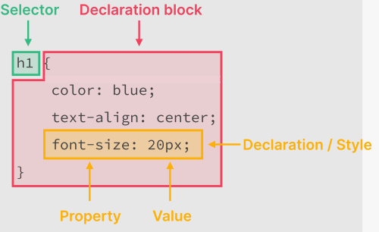

## Inline vs Internal vs External CSS

|  |  |  |
| --- | --- | --- |
| **Inline** | **Internal** | **External** |
| CSS that are within the opening tag of a HTML element | CSS that are within the <head> of a .html file | CSS that are in its own isolated .css file and included into the .html file |
| Eg.  <h1 **style=”font-transform: uppercase”** /> | Eg.  <head>  **<style>**  **h1 {**  **font-transform: uppercase;**  **}**  **</style>**  </head> | Eg. **style.css**  **h1 {**  **font-transform: uppercase;**  **}**  index.html  <head>  <link href=”style.css” rel=”stylesheet”/>  </head> |

## Selectors

|  |  |  |
| --- | --- | --- |
| **Name** | **Syntax** | **Description** |
| Element Selector | h1 {…} | Select elements by its type |
| Class selector | .primary-header {…} | Select elements by its class |
| ID selector | #author {…} | Select elements by its ID |
| List selector | h1, h2, h3 {…} | Select elements that satisfying any selector included above |
| Descendent selector | article p {…} | Select the child element of an enveloping element |

## Pseudo-classes

Keywords that can be added to a selector to specify the state of the element you are selecting for

* Eg. *li:first-child*: Select a list item element that is the first child of its parent element

## Hyperlinks

When styling an anchor (ie. hyperlink) element, we must take care of its 4 states:

* :link, :visited, :hover, :active
  + :link -> Selects anchor that are actually a link (ie. has href attribute)
  + :active -> Selects anchor that are currently being clicked
* The element is expected to be styled differently for each state and the styling should be done in the above order

## Theory 1 – Conflicts between Selectors and Stylings

When there are >1 selectors selecting an element, all of them applies to it

For any rule that is in conflict (ie. font-size: 10px; and font-size: 15px;), resolve them with the following diagram:

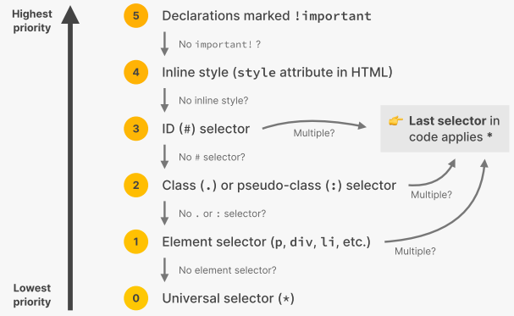

* For selectors of differing priorities, the highest priority wins.
  + The more specific a selector, the higher priority the styling is
* For selectors of the same priority, the latest selector wins.

## Learning points in Challenge #1

* Use **hexadecimal to represent colors**
* **text-transform**: uppercase
* **text-align** not align-text
* **text-decoration**: underline
* **Use classes whenever possible**, don’t be too general
* **list-style-type** to adjust the bullet point shapes (PUT IN LIST INSTEAD OF LIST ITEMS)
* **cursor: pointer** to change cursor to pointing finger when hovering a button

## Theory 2 – Inheritance and Universal Selector

### Inheritance

Certain properties from the parent elements are passed down to the child elements

* Mostly properties related to text
  + font-family, font-size, font-weight, font-style, color, line-height, letter-spacing, text-align, text-transform, text-shadow, list-style, etc.
* Inherited properties have the lowest priority, easily overwritten

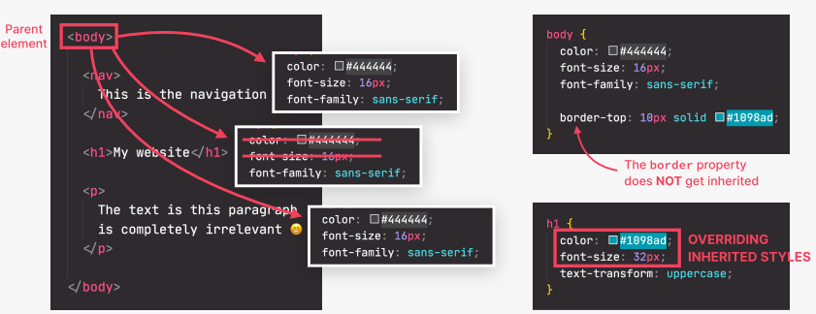

This means that we **can propagate styling downwards in a similar fashion as event delegation** in JavaScript

## Universal Selector

* {…}

Allow us to apply style to every element in the page but without any inheritance happening

* Useful for applying properties where it cannot be inherited
* Opposite of applying to *body* to let the properties be inherited by child elements

## Theory 3 – CSS Box Model

Defines how elements are displayed on a page and how they are sized. Each element on the page can be seen as **a rectangular box that has content, a border and space inside and outside of it**:

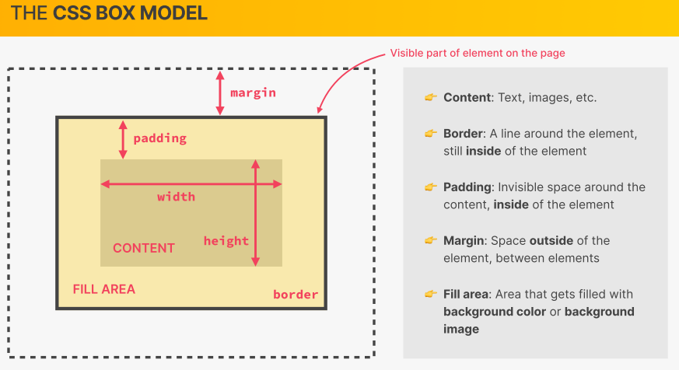

* **Padding**: Spacing between the content and the border (Internal spacing)
* **Margin**: Spacing between the border and the nearby elements (External spacing)

### Box model – content-box

$$Width=left border+left padding+defined width+right padding+right border$$

$$Height=top border+top padding+defined height+bottom padding+bottom border$$

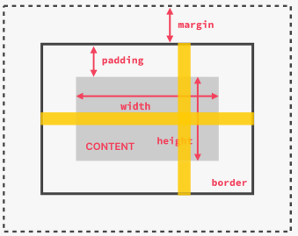

* *Box-sizing: content-box*
* All the above values can be modified via CSS

### Box model – border-box

Defined width and height include the padding and borders of the box (ie. Whatever width and height that are defined, it will be the final width and height)

$$Width=defined width$$

$$Height=defined height$$

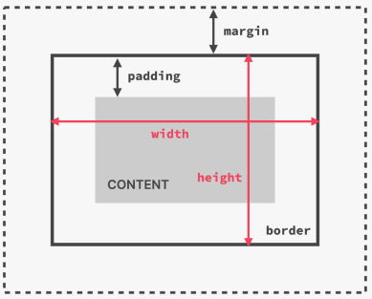

* *Box-sizing: border-box;*
* Most CSS developers just set this to all elements using the * universal selector

### Setting dimensions (width & height)

Width & height can be set to several units:

|  |  |
| --- | --- |
| **Px** | Pixels, doesn’t scale with window size |
| **%** | Percentage of the parent element’s height |
| **auto** | Scale automatically with the element’s content and other properties |

**Note**. Remember that these heights are just the defined dimensions not the final dimensions.

### Margins and Paddings

#### Global reset

A common practice to reset all paddings and margins to 0 using the universal selector

* {padding: 0; margin: 0}

🡪 Provide a clean slate for the developers to work from and give explicit paddings and margins

#### Collapsing margins

When neighboring elements have margins that overlapped with one another, only the larger margins will be displayed and the smaller one will be ignored

* Eg. margin: 40px vs margin: 15px => margin: 40px will be displayed

## Trick to center a page’s content

1. Encapsulate the content into a blank container element like a <div>
2. Style the div to have
   1. Fixed width (Stop content from stretching)
   2. Auto left-right margin (Automatically balanced the left and right margin, giving the illusion of centering the container)

## Theory #4 – Types of boxes an element can be in

An element can be displayed in 3 different types of blocks:

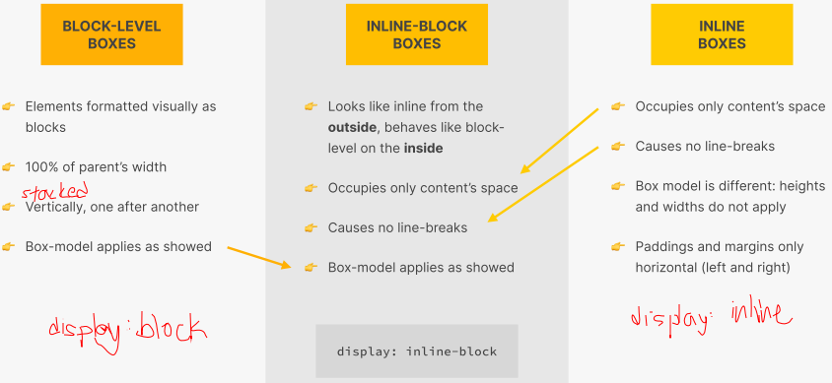

* By default, an element uses either block-level or inline boxes
* Can be modified but in normal use cases, shouldn’t modify

## Theory #5 – Absolute positioning

An element has 3 forms of positioning: Normal, Relative, and Absolute

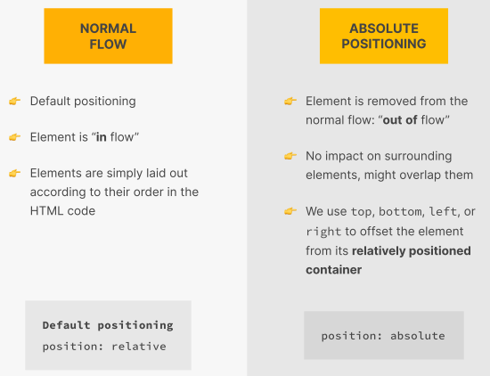 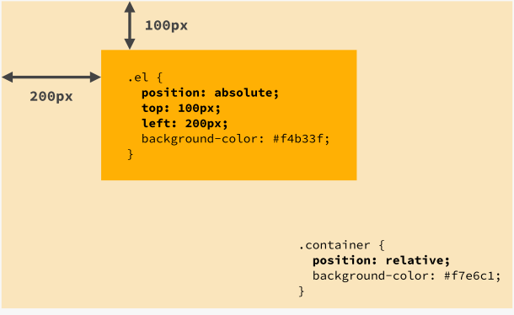

* **Normal position**: Default, position according to the flow of the document
* **Relative position:** 
  + Position according to the flow of the document
  + Can apply offset relative to itself to adjust its position (top, right, bottom, left)
* **Absolute position:**
  + Remove the element from the standard flow of positioning
  + Has no impact on surrounding elements
  + Can apply offset relative to closest positioned ancestor or the initial containing block (top, right, bottom, left)

## Pseudo-element

Elements that don’t exists in the HTML but that we can still select and style in CSS

**Examples**

::first-child, ::first-letter, ::before (Creates an element as the first child for the selected element), ::After (Similar to ::before but as the last child for the selected element)

# Extracts from the Advanced CSS Course

## What happens to HTML and CSS upon page load

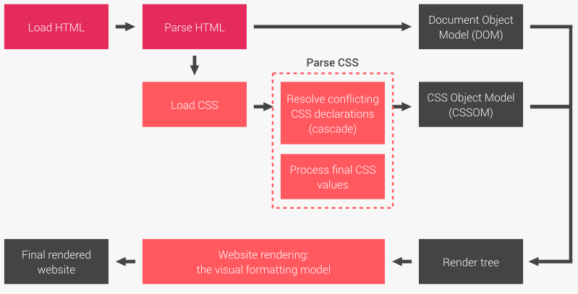

When the HTML and CSS are loaded, they are parsed to form their respective object models

* When parsing a CSS, there are mainly 2 processes
  + Resolving conflicting CSS declarations (Cascading)
  + Processing final CSS values

## Cascading

A process of combining multiple stylesheets together and resolving the conflicts it has between different CSS rules and declarations when they are applied to an element

* Ie. Declarations from a CSS rule conflicts with declarations from another CSS rule, we need cascade to decide which declaration the element will use

### Sources of CSS declarations

|  |  |
| --- | --- |
| **Author** | Declarations written by the developers within the .css files |
| **User** | Declarations written by the users outside of the .css files  (eg. Declaring in Chrome devtools) |
| **Browser** | Default declarations that a browser made as a baseline |

### Cascading flow

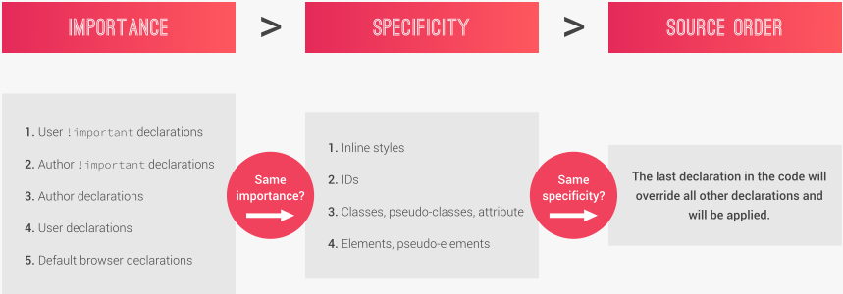

#### Importance

* Author declarations & User declarations are basic declarations without any !important

#### Specificity

Specificity of an element is determine based on how many different types of selectors were used in the CSS rule:

**(# of inline styles, # of IDs, # of classes/pseudo-classes/attribute, # of elements/pseudo-elements)**

We then compare the # of selectors of each type between the conflicting declarations. The declaration with higher number of more specified selector wins the conflict.

Eg.

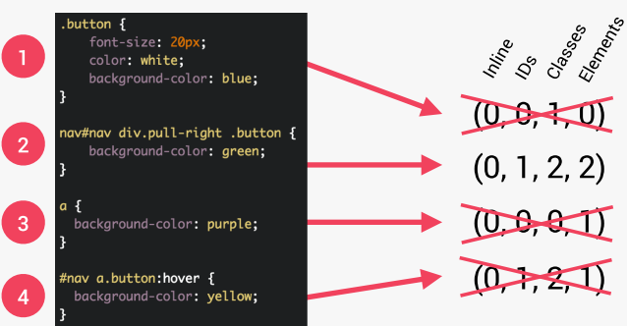

# Section 4 – Layouts: Floats, Flexbox and Grid

## 3 ways of building layouts

1. Floats
2. Flexbox
3. Grid

## Floats

A CSS property to remove an element from the normal flow, but allow other elements to wrap around it (Unlike absolute positioning)

$$float:left/right/none$$

Note. If all elements in a container float, the container element will **collapse**

### Clear float

A CSS property that set whether an element must be moved below floating elements that precede it

$$clear:both$$

* Can be applied to floating or non-floating elements
* Element that is being cleared must be a block element
* Can be applied to a pseudo-element if there isn’t any element to keep the container element stretched

## Flexbox

A set of related CSS properties for building 1-dimensional layouts

* Based on the idea of distributing empty space in a container element to its child elements
* Make floats obsolete

### Components of a flexbox

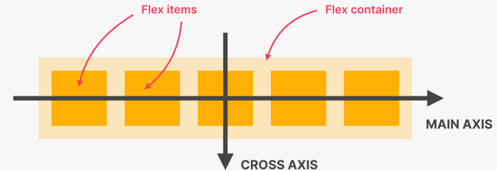

* *flex-direction* determines which axis will be the main axis and cross axis
  + Affects justify and alignment of items

### Properties

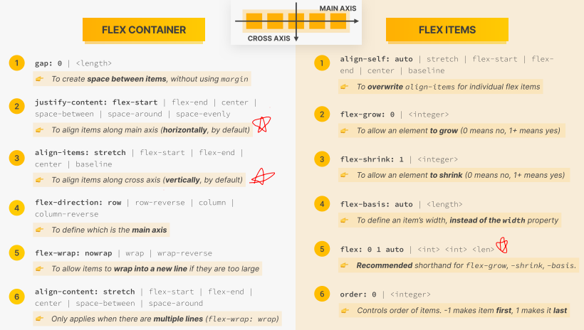

#### Flex shorthand

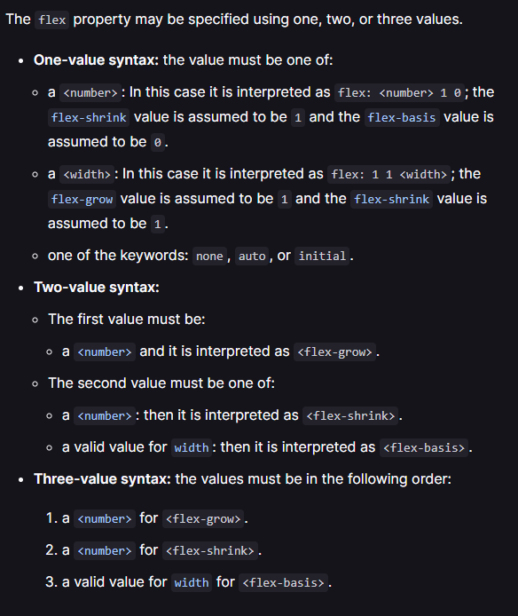

* *flex: 1 ⬄ flex: 1 1 0 ⬄* All flex-items has the same size regardless of content

## Grid

A set of CSS properties for building 2-dimensional layouts

* Based on the idea of dividing a container element into rows and columns that can be filled with child elements
* Not meant to replace flexbox
  + 1D layout: flexbox
  + 2D layout: grid

### Components of Grid

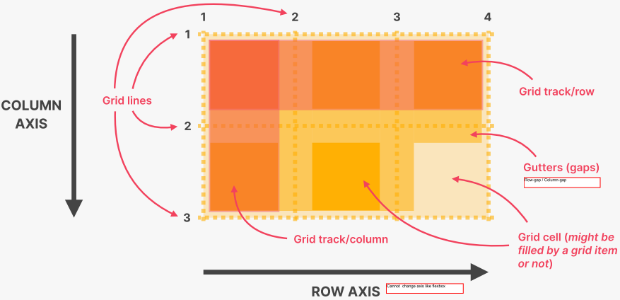

* Unlike flexbox, the grid’s axis cannot be changed
* Gutters ⬄ Row gap or Column gap
* Each grid line is labelled with a positive and negative line number, both count from opposing directions

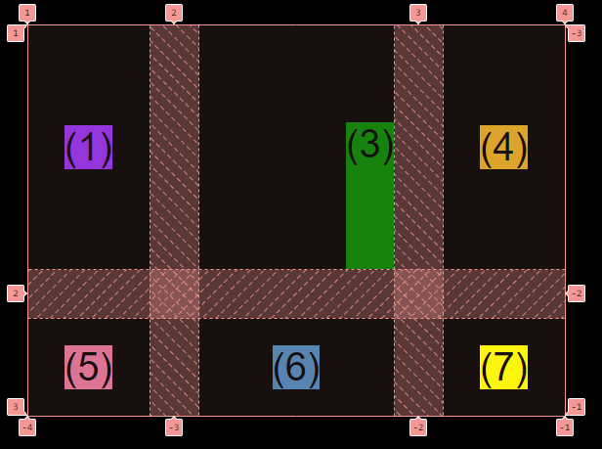

### Properties

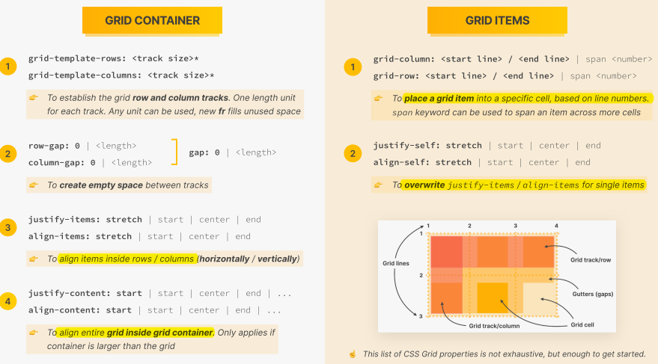

#### Fr & auto

fr 🡪 A proportion value that we can give to distribute free space across a grid’s rows or columns

auto 🡪 Specify that a row/column will take the exact amount of space needed for its content

#### Repeat(…)

For grid-template-columns and grid-template-rows, if we have columns/rows with same distribution, we can declare them one-shot as follows:

$$repeat(\# OF TIMES, PROPORTION VALUE)$$

#### Spanning a grid item across a row or column

$$grid-row: 1 / -1$$

$$grid-row: 1 / span 3;$$

# Section 5 – Web design rules and framework

## Good vs Bad design

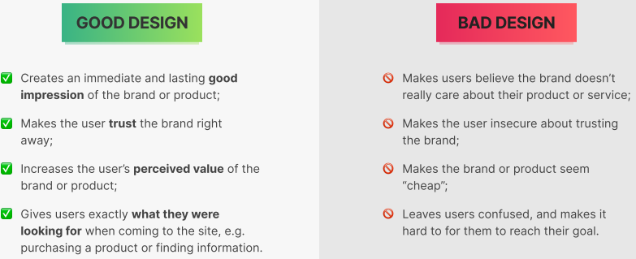

## Web design ingredients

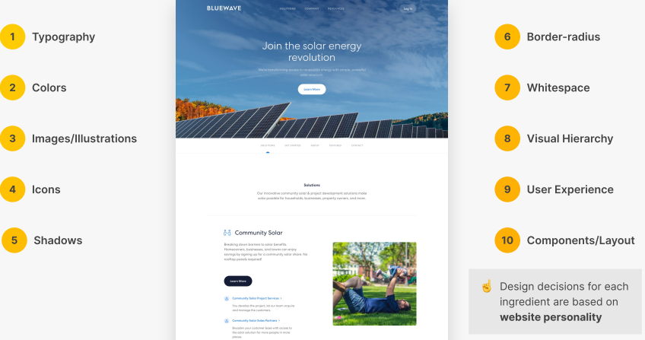

## Website personalities

Refer to the lecture slides for examples of each website personality

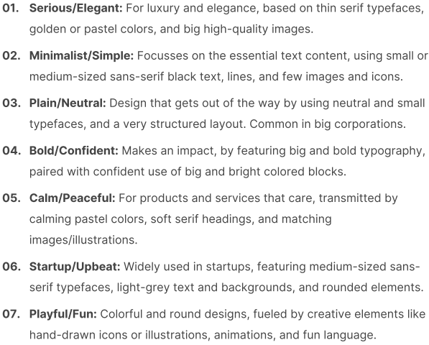

## Typography

The art and technique of arranging type to make written languages legible, readable, and appealing when displayed

### Serif vs Sans-serif typefaces

|  |  |
| --- | --- |
| **Serif typefaces** | **Sans-serif typefaces** |
|  |  |
| * Gives a traditional/classic look and feel * Conveys trustworthiness * Good for long text | * Gives a modern look and feel * Clean and simple * Easier to use for beginner designer |

### Guidelines

#### Typefaces

1. Use only good and popular typefaces to play it safe
   * Can refer to the lecture slides or websites like Google Fonts and Font Squirrel
2. Stick to 1 or 2 typefaces per page
3. Choose the right typeface according to the website’s personality and message

#### Font sizes and weights

1. Limit your choices by referring to Type Scale tools or some pre-defined range

Eg.

SPACING SYSTEM (px)

2 / 4 / 8 / 12 / 16 / 24 / 32 / 48 / 64 / 80 / 96 / 128

FONT SIZE SYSTEM (px) from type-scale.com

10 / 12 / 14 / 16 / 18 / 20 / 24 / 30 / 36 / 44 / 52 / 62 / 74 / 86 / 98

1. For “normal” text, use font size between 16px and 32px
2. For long text (eg. blog post), use font size of at least 20px
3. For headlines, can use font size of 50px or more with a weight of 600 or more
   * Depending on the website’s personality

#### Readability

1. Use < 75 characters per line
2. The smaller/longer the text is, the larger the line height needs to be
   * For “normal” text, use a line height between 1.5 and 2.
   * For “big” text, use a line height below 1.5
3. Decrease the letter spacing in headlines if it looks unnatural
4. For short titles, experiment with all caps, small, and bold fonts with increased letter-spacing
5. Usually, don’t justify text
6. Centering text should only be for smaller text blocks

## Colors

### Guidelines

#### Choosing the right color

1. Pick a main color that match the website’s personality

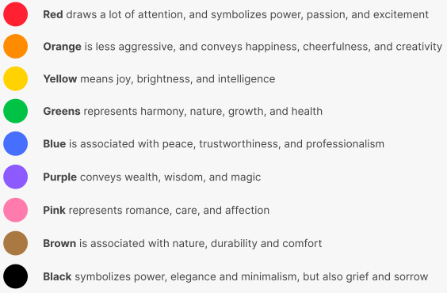

1. Use a tone of the main color by referring to tools like OpenColor, TailwindCSS, and Flat UI

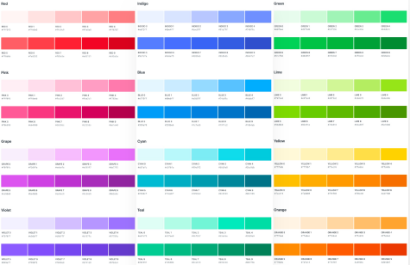

#### Establishing a color system

1. Pick a grey color for the color palette
2. Pick an accent (secondary) color for the color palette through tools like Coolors and Palleton
3. Improve the color palette’s diversity by picking lighter and dark versions of the picked colors
   * Tints: Lighter versions of the colors
   * Shades: Darker versions of the colors

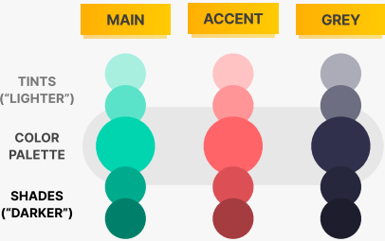

#### When and how to use colors

1. Use your main color to draw attention to the most important elements on the page



1. Use your accent colors to make components or sections stand out

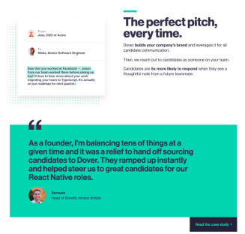

1. Can try to use images and illustrations with supporting/consistent colors to the palette

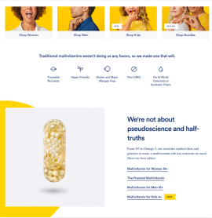

#### Colors and typography

1. On dark colored backgrounds, can use a tint of the background for text color

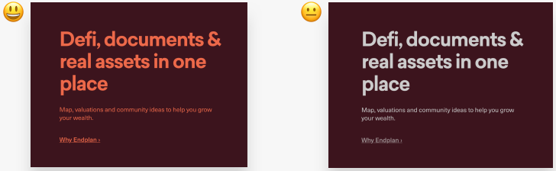

1. Text should usually not be completely black, can try a lighter version to be less heavy
2. Establish enough contrast between text and background colors
   * At least 4.5:1 for normal text and 3:1 for large text (Can use tools like Coolors)

## Images and Illustrations

### Guidelines

#### Choosing images

1. Choose 1 of 4 image types: **Product photos, Storytelling photos, Illustrations, Patterns**

 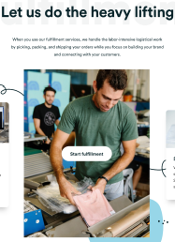

 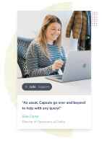

1. Choose images that are **relevant and support your website’s message and story**
2. Prefer **original** images or **original-looking stock** images
   * Tools: Unsplash, Pexels, DrawKit, unDraw

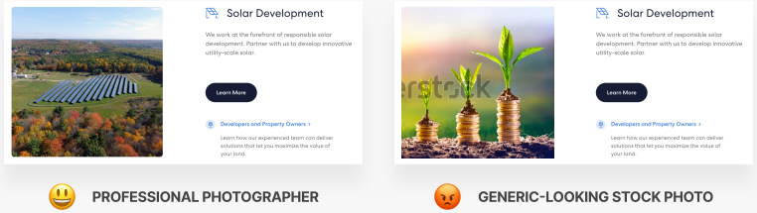

#### Using images

1. Use images that **show real people to trigger user’s emotions**

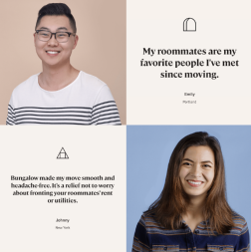

1. **Crop** the image to fit your message if necessary
2. Can try to **combine** photos, illustrations, and patterns for better effect



#### Handling text on images

1. Method 1: **Darkening/Brightening** **the image** completely/partially using a gradient



1. Method 2: Placing the text in the image’s **neutral area**

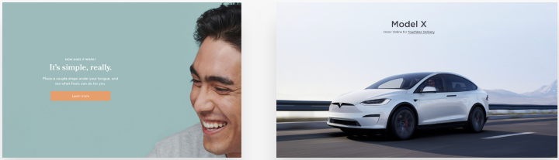

1. Method 3: Placing the text in **a box over the image**

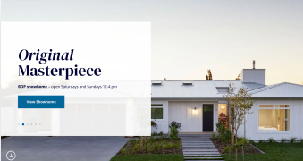

#### Technical details

1. Image’s dimension should be **2x of their displayed size** to support high-res screens
2. Images should be **compressed** for a lower file size and better load performance
   * Tool: Squoosh
3. Ensure that images that are placed side-by-side have the **same dimensions / aspect ratios**

## Icons

### Guidelines

#### Picking icons

1. Use an icon pack
   * Resources: Phosphor icons, Ionicons, IconS8 etc
2. Use **only 1 icon pack** and not mix the icons from different icon packs
3. Use **SVG icons or icon fonts** instead of bitmap image icons (eg. .jpg, and .png)

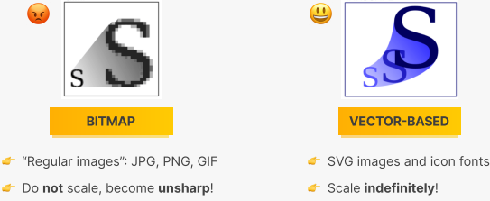

1. Choose an icon pack that **fit the website’s personality**
   * Refer to the typography’s roundness, weight, and filled/outlined

#### When to use icons

1. Use icons to **provide visual assistance** to the text



1. Use icons to **present product feature blocks**



1. Use icons to **represent actions**, and label with text (Unless no space or icon is 100% clear)
   * Don’t mix label and unlabeled icons together

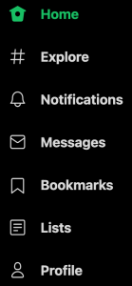

1. Use icons as **bullet points**

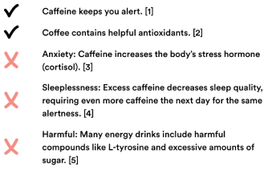

#### How to use icons well

1. To keep icons **neutral**, use **same color** as text. To **draw more attention**, use **different color**

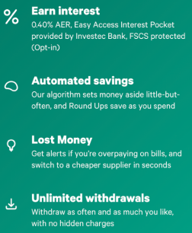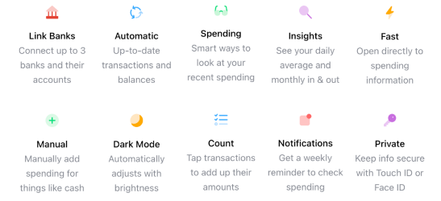

1. Icons must **make sense and fit the text/action**
2. **Don’t enlarge the icons further** than what they **were designed for**
   * Can enclose them in a larger shape to make it “larger”
   * Icons with a lot of details and thin lines are to be used in a larger size

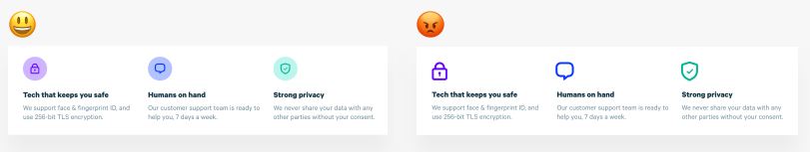

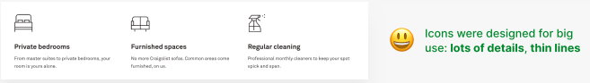

## Shadows

By adding more shadow, the further away the element seems from the interface:

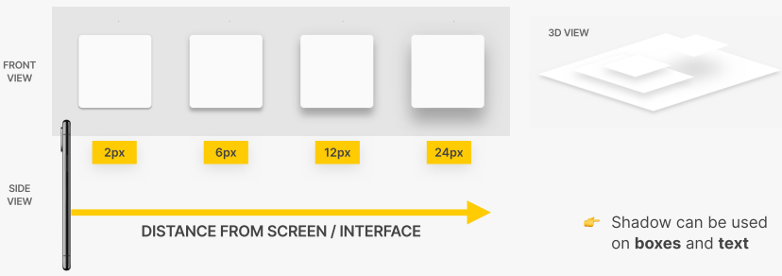

**Note**. In webpages, we assume the light source comes from top-down. Most elements’ shadows will only offset vertically.

### Guidelines

1. Shadows is not a must, only use them if it **makes sense for the website’s personality**
   * The more serious the website less, the less shadow the website has

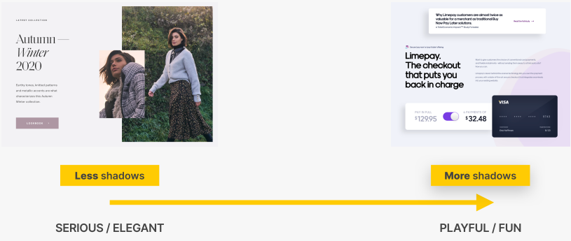

1. Use shadows **in small doses**, don’t use it in every element
2. Keep the shadow to be **lighter** than darker
3. Use **small shadows for smaller elements** to stand out

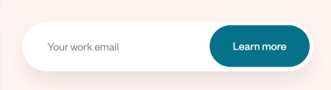

1. Use **medium shadows for larger areas/sections** to stand out more

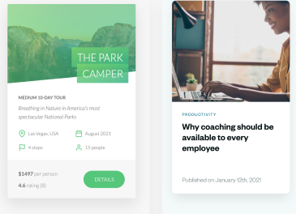

1. Use **large shadows for elements that are floating** above the interface

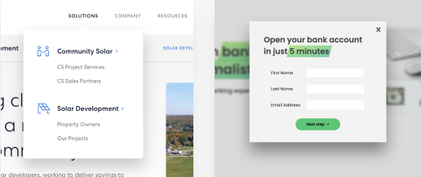

1. Experiment with **shadow strengths** to visualize interactions (eg. Click and Hover button)

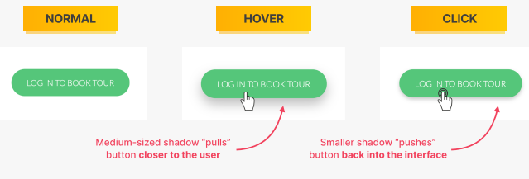

1. Experiment with **glows (ie. colored shadows)** for interesting visuals

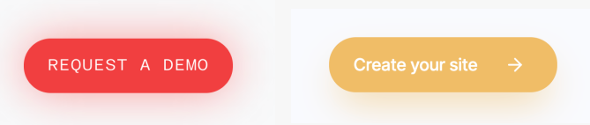

### CSS property

*box-shadow: HORI_OFFSET VERT_OFFSET BLURNESS SCALE COLOR*

*text-shadow: HORI_OFFSET VERT_OFFSET BLURNESS COLOR*

## Roundness (Border-radius)

### Guidelines

1. Use roundness to **increase the playfulness/fun** of the design, making it **less serious**

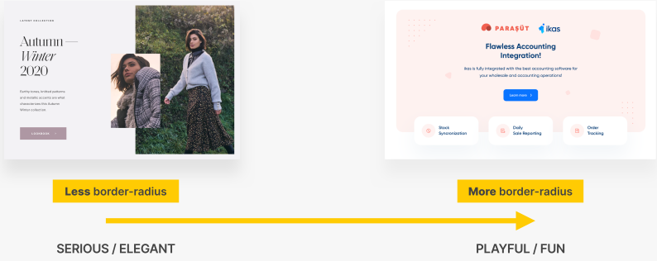

1. Roundness of the elements should **match the roundness of the typefaces**

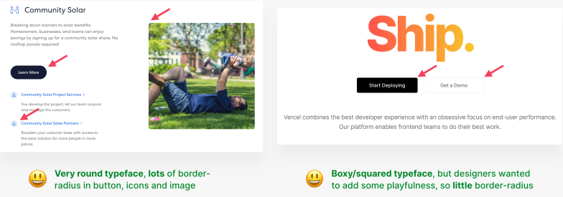

1. Use roundness on **buttons, images, icons, sections** etc

### CSS properties

*border-radius: AMOUNT_IN_PX;*

* A large enough border-radius can completely circle-fy the corners
* Individual corners of the element can be circle-fy or straighten:

*border-top-left-radius: AMOUNT_IN_PX;*

*border-top-right-radius: AMOUNT_IN_PX;*

*border-bottom-left-radius: AMOUNT_IN_PX;*

*border-bottom-right-radius: AMOUNT_IN_PX;*

## Whitespace

### What it does

* The right amount helps to make design look **clean, modern, and polished**
* Helps to **communicate how different piece of information are related** to one another
* **Implies invisible relationships** between the elements of a layout

### Guidelines

#### Where to use whitespace

1. Use **tons of whitespace between sections**
2. Use **lots of whitespaces between groups of elements**
3. Use **whitespace between elements**
4. Within groups of elements, **use whitespace instead of lines** to separate them

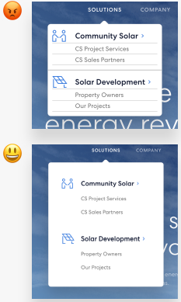

#### How much whitespace to use

1. The more some elements/groups of elements **belong together, the closer they should be**
   * Law of proximity

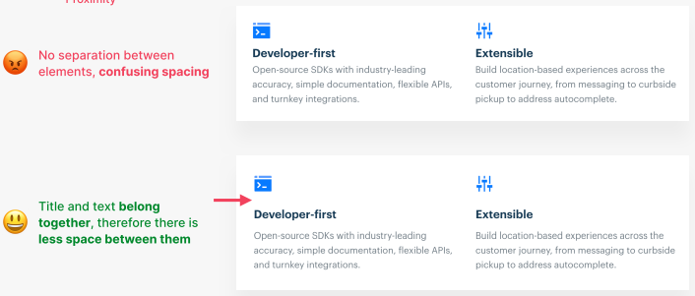

1. **Start with excessive amount** of whitespace, then cut down from there
2. **Match other design choices**. If you have big elements (eg. Text or icons), more whitespace

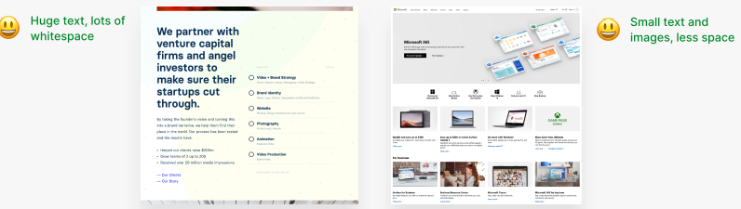

1. When it comes to the specific amount of spacing, try **use a hard rule** (eg. Multiples of 16px)

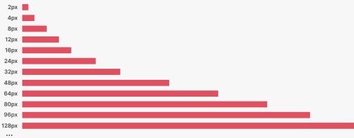

## Visual Hierarchy

Establishes which elements/components of a design are the most important ones by drawing attention to them using a combination of position, size, colors, spacing, borders, and shadows

* Defines a “path” to guide the users through the page

### Guidelines

#### Fundamentals

1. Position **important elements closer to the top of the page**, where they get more attention
   * **User’s attention flow down** the page and its components

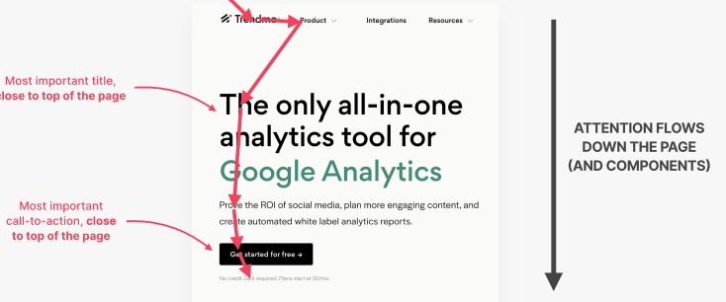

1. Be mindful of **image** usage, as they can **draw a lot of attention**
   * Smaller images can be used to draw lesser attention

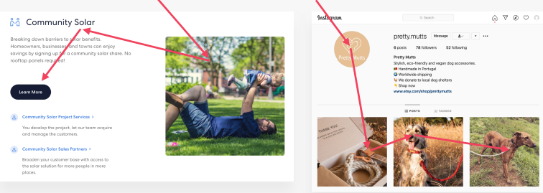

1. Use **whitespace** strategically to **separate and emphasize elements** of a page

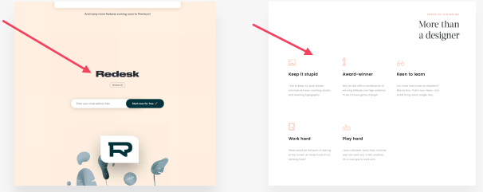

#### For text elements

1. Use **font size, font weight, color, and whitespace** to **convey importance** of text

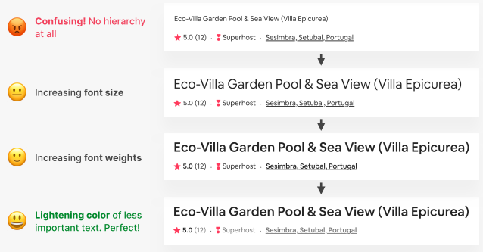

1. Can **emphasize important** texts (eg. Titles, sub-titles, links, buttons, data points, icons) and **de-emphasize less important** texts (eg. Labels, secondary/additional information)

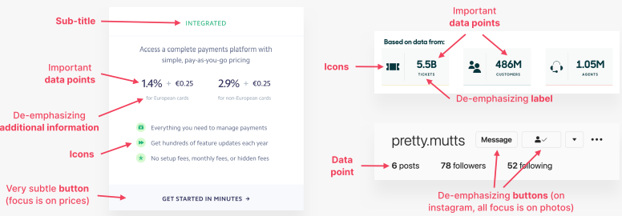

#### Between components

1. **Emphasize important** components using **background color/shadow/border** or **de-emphasize the less important** components

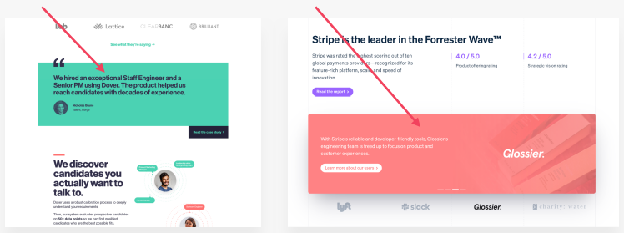

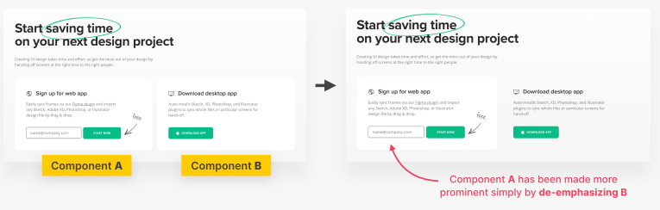

1. Can emphasize components like **Testimonials, Call-to-action sections, Highlight sections, Preview cards, Forms, Pricing tables, Important rows/columns in tables** etc

## User experience (UX)

The overall experience the user has while interacting with a product

* Guided by the aim of aligning the user’s goal for visiting the webpage and the business’s goals for creating it

### Guidelines

#### Usability

1. **Don’t reinvent or use overly complicated layouts**. Use layouts that users are familiar with
2. Make **call-to-action** the **most prominent** element and make the **text descriptive**

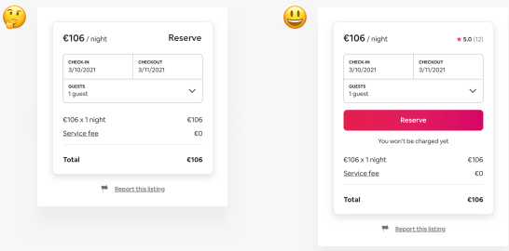

1. **Animation** should have a **purpose** and be **fast** (ie. 200 – 500ms)
2. In forms, **labels and fields should be aligned** in a single vertical line to make it easier to scan

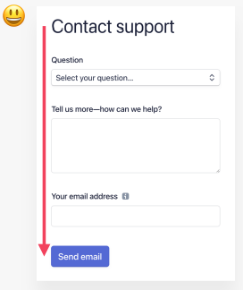

1. Offer user with **effective feedbacks** for all actions (eg. Form errors, Form success)
2. **Place user actions in context** where they will create the effect (ie. Law of locality)

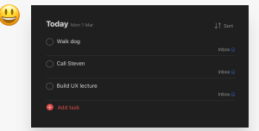

#### Website content

1. Keep the **headline descriptive** and **keyword-focused**

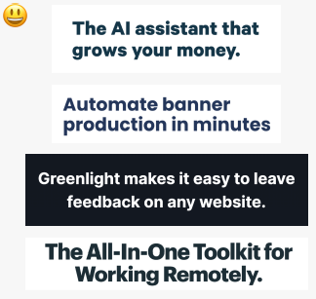

1. Only **include relevant information** and **cut out fluff** to keep the content clear and efficient
2. Use **simple and clear words**, avoid technical jargon that might confuse the users
3. **Break up the content** with sub-headings, images, block quotes, bullet points etc

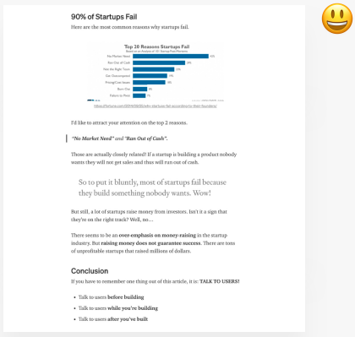

## Website personalities framework

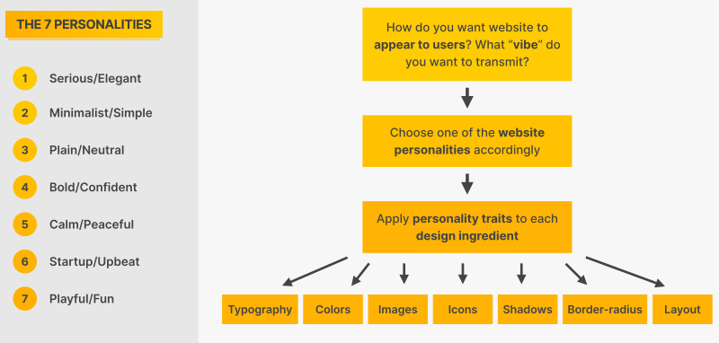

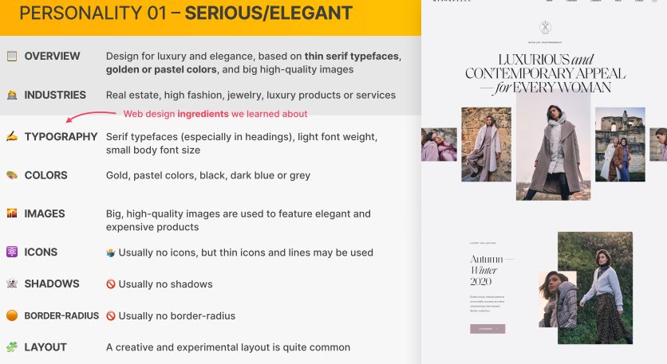

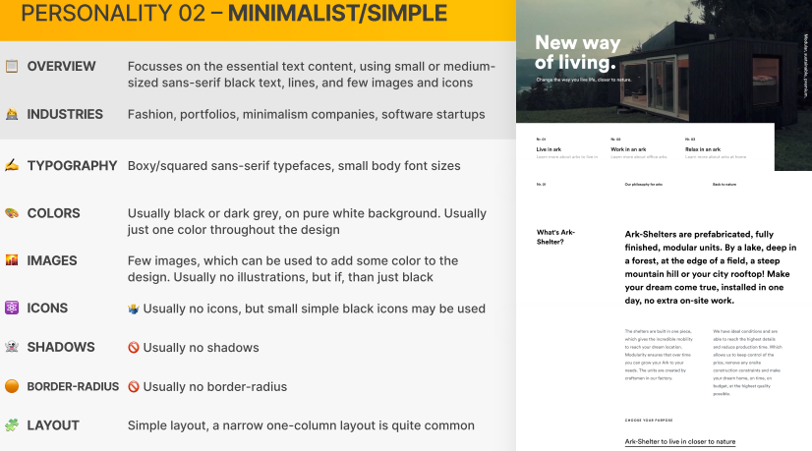

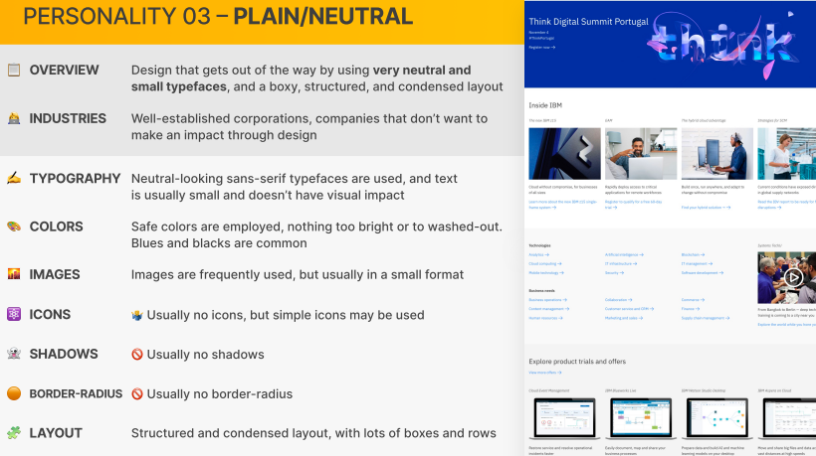

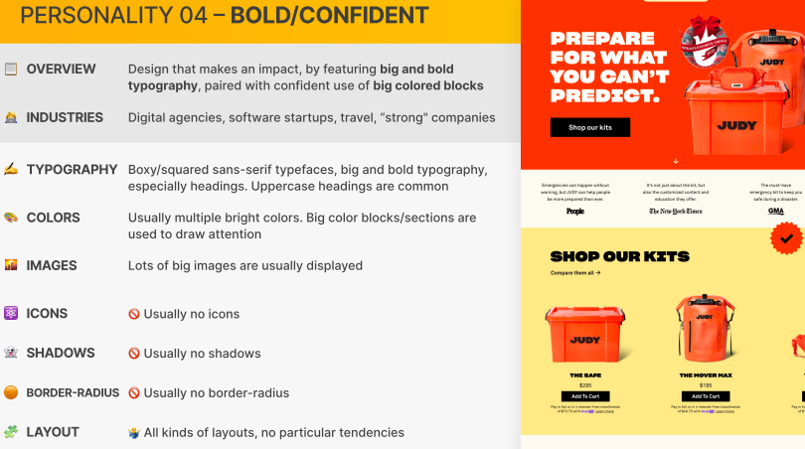

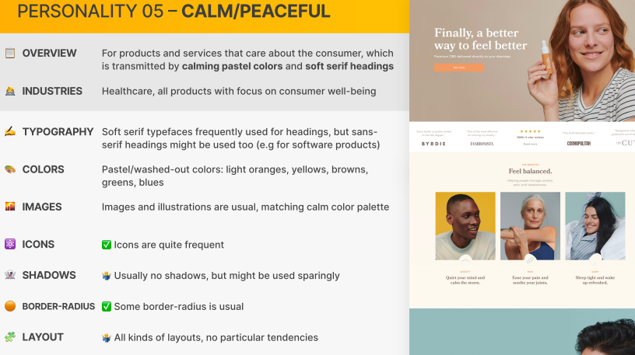

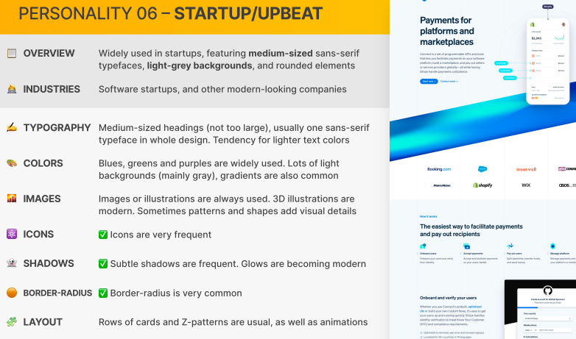

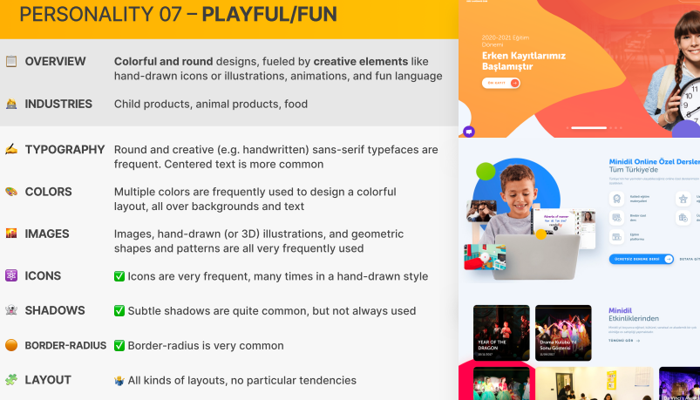

### Combining playfulness and boldness in website’s personality

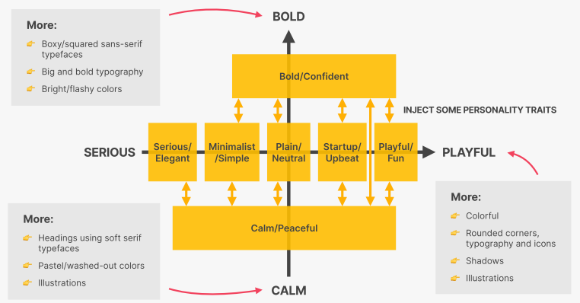

# Section 6 - Elements, Components, and Layouts

A webpage is assembled using 1 or more layout areas that are combined from components which are composed of elements and smaller components

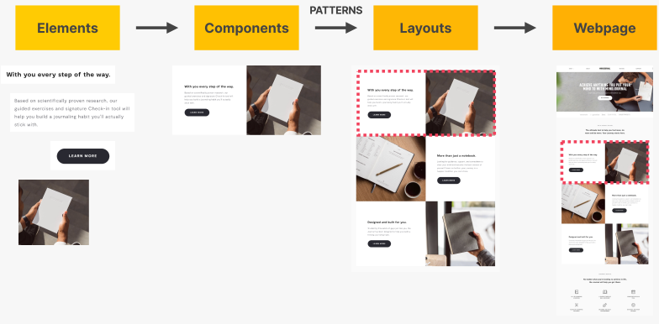

## Elements, Components, and Layout patterns (Non-exhaustive)

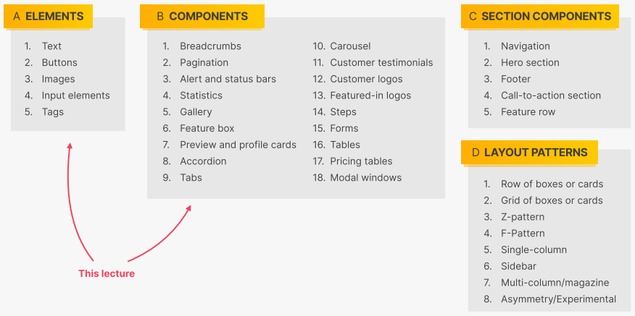

**Note: For visual examples, refer to the lecture slides**

### Notes from Accordion (Component)

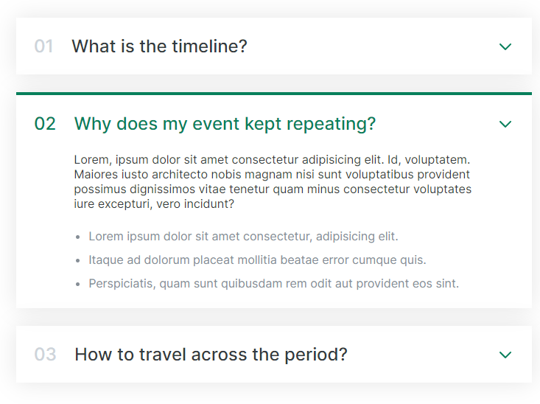

* Center an element by setting its horizontal margin to be *auto*
  + Eg. *margin: 100px auto;*
* Insert gaps between the children elements using flexbox
  + Eg. *display:* flex; *| flex-direction: column; | gap: 12px;*
* Add a new class to customize how an element look in another state
  + Eg. Add *open* class and having its styling allow us to style how the element look when it is opened

### Notes from Carousel (Component)

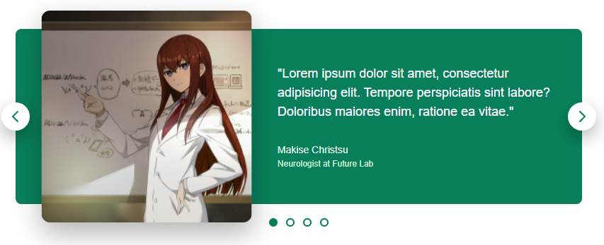

* When there is an **absolute positioned element**, there should be **a parent element that is set to positioned relatively**
* ***transform*** – A CSS property that allow us **to rotate, skew, scale or translate a transformable element** (eg. *translate(50%, 10%))*
  + **In relative to the element itself**
  + The transformation does not affect the element’s box model (ie. Transform the appearance but not influencing the document flow)
* Can remove a HTML button’s default bevel border with *border: none*
* *border-radius: WIDTH_OR_HEIGHT_OF_ELEMENT* to make an element **circular**
* *left/right/top/bottom* properties **position the element’s left/right/top/bottom** to the specified amount of the parent’s container
  + **In relation to the parent element**
* *cursor: pointer* to change the cursor into a finger that is going to click

### Notes from Pagination (Component)



* Remember for **anchor element**, you need to style the 4 states (**link, visited, active, hover**)
* ***display: flex*** can **position the inner text content** **of an element** (Not referring to its child elements)
* CSS selector can **chain from a selector with pseudo class to allow us to apply style to a child element when a parent element is in a certain state**
  + Eg. *.btn:hover .btn-icon*

### Notes from Hero Section (Section Component)

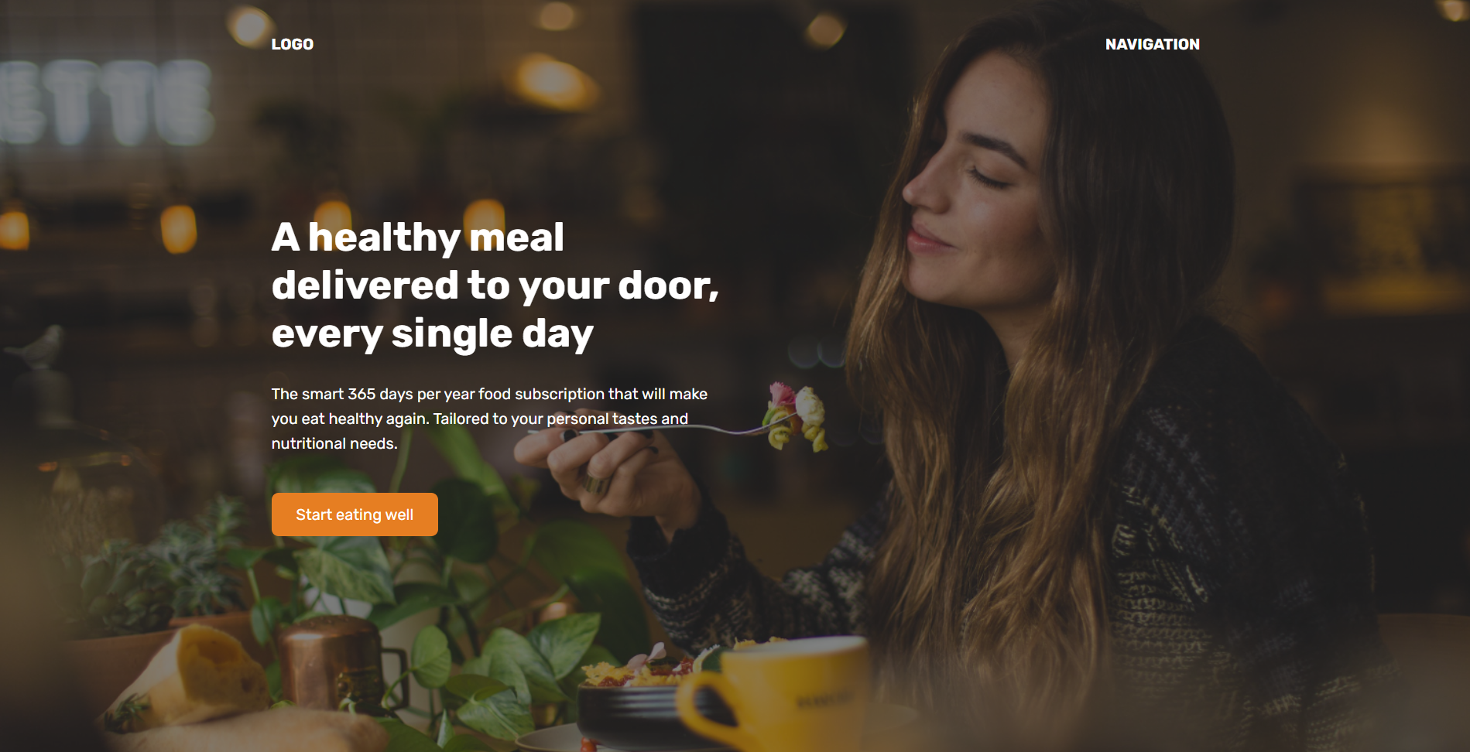

* **Can stack images in the *background-image* property** with the first value as the top of the stack and so forth
  + Eg. *background-image: linear-gradient(black, white), url(“cat.jpg”);*
* For **buttons**, the inner padding tends to be **horizontal padding 2x more than vertical padding**
  + Eg. *padding: 16px, 32px;*
* Remember **setting *display: inline-block* allows vertical padding to be considere**d for inline elements
* For certain styling that will be applied across multiple elements, can consider having them in a **utility class in CSS**
  + eg. *.container { margin: 0 auto; width: XXXpx; }*
* Can use **absolute position + transform** to **center an element vertically and horizontally**
* Can **enclose the content with an inner container** within the original parent container to **adjust the sizing**
  + Eg. *.header-container-division { width: 50%; }*

### Notes from Web Application Layout

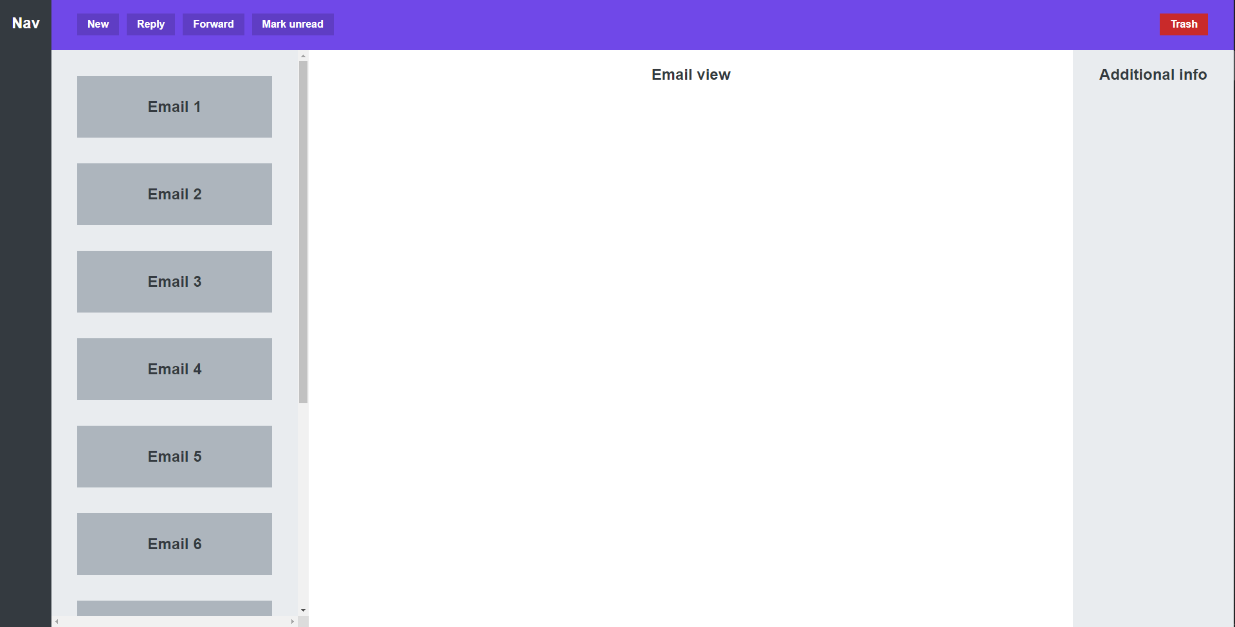

* ***margin-left/-right/-top/down*** can be **assign with *auto* to receive a share of the remaining space** around the element
* If a flex container has a limited height, we **can set *flex-shrink* to 0 to prevent flex items from shrinking when their total heights exceed the container**
  + *overflow* property of the container can be set to *scroll* to allow scrolling of the container

# Section 7 – Omnifood project – Desktop version

## Responsive Design

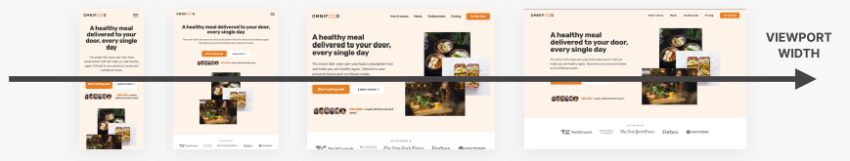

* A set of practices to make a webpage adjust its layout and visual style to fit any possible viewport sizes
  + Allowing websites to be usable on all devices (eg. Desktop, Tablets, Phones)
  + Done through CSS
* Ingredients
  + Fluid layouts
    - **Using *%/vh/vw* units instead of px** for elements to adapt to viewport size
    - Use *max-width* instead of *width*
  + Responsive units
    - **Use *rem* instead of *px*** for most lengths to allow easier layout scaling automatically
    - Trick: Set *1 rem* to *10* *px* for easy calculations
  + Flexible images
    - By default, images does not scale automatically with viewport size
    - **Must use *%* together with *max-*width for image dimensions** to auto-scale
  + Media queries [KEY THAT MAKE THIS POSSIBLE]
    - **Change CSS stylings based on viewport width** (ie. breakpoints)

## Desktop-first development vs Mobile-first development

|  |  |
| --- | --- |
| **Desktop-first** | **Mobile-first** |
| Start designing the CSS for the desktop version (w/ larger screen)  Then, use media queries to shrink design for smaller screens  Easier to start and learn from | Start designing the CSS for the mobile devices (w/ smaller screen)  Then, use media queries to expand design for larger screens  Force us to reduce the websites and apps to the absolute essentials right from the start |

## Steps to build a website

### (1) Define the project

* Define **who the website is developed for**
  + eg. Yourself, Client, Business
* Define **what the website is for**
  + ie. Define the business and user goals of the website
* Define the **target audience of the website**, be as specific as possible
  + Eg. Women, 20 to 40 years old, earning over 2000/month with a passion for dogs

### (2) Plan the project

* **Plan and gather the website’s content** such as text, images, videos etc
  + Can be provided by client or gather ourselves
* **Plan out a sitemap** which includes the pages the site has and how they relate to one another
  + For each page, we may plan its sections and in what order to better convey the content’s message
* **Define the website’s personality**

### (3) Sketch layout and component ideas

* Think about **what components the website needs** and how you will use them in **layout patterns**
  + Can look for inspirations
* **Sketch out any idea** on pen and paper or on software like Figma
  + Don’t need sketch everything or be perfect
* An **iterative process** with (4)

### (4) Design and build website

* **Design and build the website** with HTML and CSS using the decisions, content, and sketches from (1), (2), and (3)
  + Design the actual visual styles for the layouts and components chosen in (3)
  + Design should be done based on the selected personality, its guidelines, and inspirations
* **Use the client’s branding** (eg. colors, typography, icons) for design decisions if there is any

### (5) Test and optimize

* Make sure the website **works in all major browsers** (eg. Chrome, Firefox, Safari, Edge etc)
* Test the website on **actual mobile devices** (not just in DevTools)
* **Optimize all images** in terms of dimensions and file size (compress them)
* **Fix accessibility problems** like color contrast issues
* Run the **Lighthouse performance test** and try to fix the reported problems
* Think about **Search Engine Optimization (SEO)**

### (6) Launching the website

* **Upload the website files** to a hosting platform (eg. Netlify)
* **Choose and buy a good domain** name that represents the brand well, is memorable and easy to write

### (7) Maintain and keep updating website

* **Keep the website content updated** over time
* **Install analytics software** (eg. Google Analytics or Fathom) to get statistics about website’s users
  + Can inform us on possible future changes to site structure and content
* If there is a blog, it needs to be **updated regularly to keep users coming back** and improve SEO

## Step 1 - Defining Omnifood

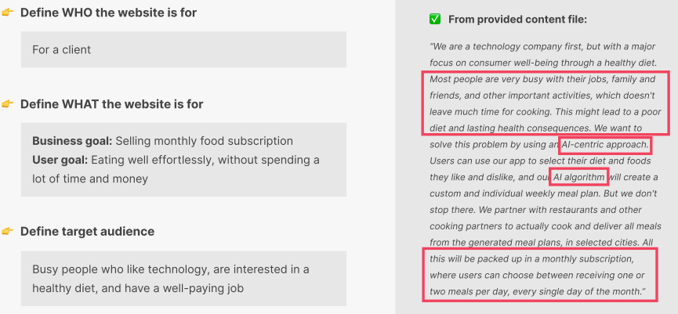

## Step 2 – Planning Omnifood

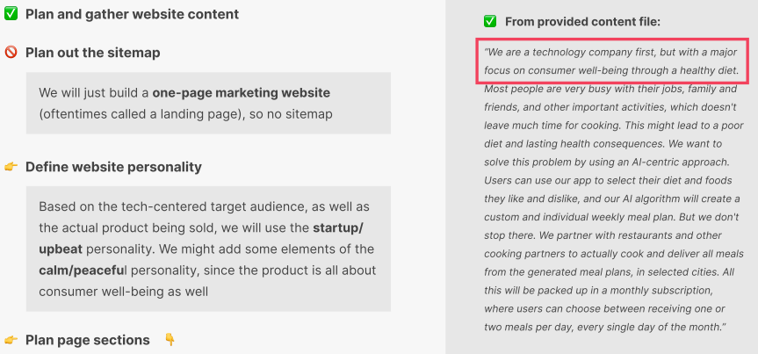

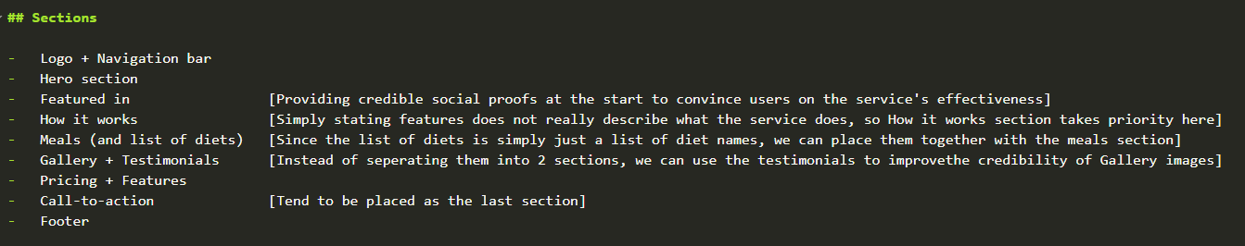

* Sections determined based on the given description of Omnifood

## Step 3 – Sketching layout and components

1. Think about what components or layouts each section of the page will have
   1. Can “copy” from inspirations
2. Merge those sections together into a page sketch

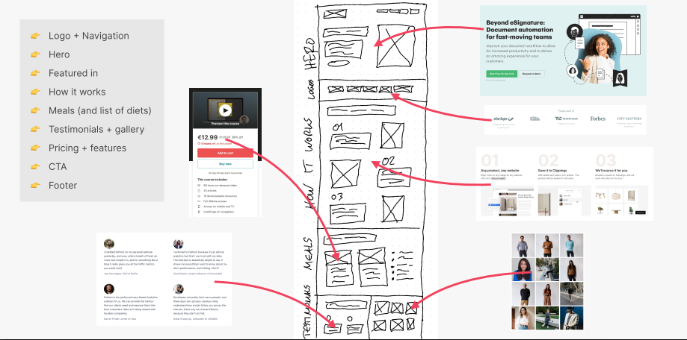

## Step 4 - Build and design website

### *Max-width*

A CSS property to set width as what’s given if possible. Else, set the width as the parent container’s width

### rem unit

A CSS unit that refers to the **font size of the root element** (ie. <html>)

* By using *rem* as our length unit throughout the page, **we can easily change the scaling of all elements** by adjusting the root element’s font size

Always try to use *rem*, following **1*rem* to 10*px*** rule

* 10*px* because is easier to convert

When setting the font-size in root element (ie. <html>), use ***%* allow us to respect the user’s definition of browser’s font size**

* By default, a browser’s font size is 16px
  + 62.5% of default font size => 62.5% of 16px => 10px
* Before elements are rendered to the page, all relative units (eg. rem, %) are converted to px

### *transition*

A CSS property for defining how an element’s CSS property will transition between 2 states of an element

* States can be defined using pseudo-classes (eg. :hover, :active) or via JS
* Syntax: PROPERTY_NAME | DURATION | DELAY | EASING_FUNCTION

### HTML Entities

A piece of text that begins with & and ends with ; that is used to represent reserved, invisible, and difficult to type characters

* Eg. *&amp;* 🡪 & | *&lt;* 🡪 < | &gt; 🡪 >
* <https://html.spec.whatwg.org/multipage/named-characters.html#named-character-references>

### Splitting CSS properties to extend stylings

We can allocate certain CSS properties into additional CSS classes that we may add onto the HTML element to customize its styling

* Eg. Having an element that display as grid using *.grid* and have additional classes like *.grid—2-cols* and *.grid—3-cols* to customize the # of columns

### Reusable/Utility CSS classes

Certain stylings are widely repeated throughout the page’s styling. We can place them in CSS classes that we can easily assign them to elements

* Eg. Container that horizontally center its contents
  + *.container { max-width: 120rem; margin 0 auto; }*

### Pseudo-elements

Elements that don’t exists in the HTML but that we can still select and style in CSS

* Eg.::before, ::After
* Cannot set percentage-based height if the parent element (ie. Owner of the pseudo element) has no fixed height
  + Use padding to fake out the height

### <figure> and <figcaption>

*<figure>* 🡪 A self-contained HTML element with content (oftenly, image) and a caption

*<figcaption>* 🡪 A HTML element within *<figure>* to represent caption

### <blockquote>

An HTML element that represents a quote

### <aside>

An element that contains some additional but not crucial information

### background-size

A CSS property that sets how the background image scales with the element

* Contain: Scale as much as possible in the container without cropping or stretching
* Cover: Scales to fill container (ie. Cover the height and width of the container completely)
* Auto: Scales automatically such that the image’s intrinsic proportions are maintained
* SPECIFIC_VALUE: Scales to fit a specified length

### background-position

A CSS property that sets the edge that the background image will align with

* Eg. top, down, left, right

### input::placeholder

A pseudo-element for <input> that allow us to style the placeholder text within an input field

* Eg. *input::placeholder { color: #aaa }*

### :focus

A pseudo-class for us to style the outline placed on a focused element

* By default, the outline tends to be ugly, and we should override them if possible
  + Properties to directly modify the outline: *outline, outline-offset*
  + Universal selector to use: *\*:focus*
* Rather than using *outline*, we can use *box-shadow* to provide an “outline” that adapts to the focused element’s shape

### ARIA role

A HTML attribute that provide a semantic meaning to the element

* Allow screen readers to support interaction that is consistent with user’s expectation of the specified role
* Can be used to describe vague elements or elements that don’t exist natively in HTML

### ARIA label

A HTML attribute that provides a label for an interactive element that is missing a description for its content

* Eg. An element that acts as *<img>* but has not *alt* attribute

### <address>

An HTML element that enclosed the contract information for a person, people, or an organization

### URL schemes in <a>’s href attribute

*href* attribute specifies the URL that *<a>* points to and it supports URL schemes supported by the browsers such as:

* Fragment URLs (ie. Those with # and points to sections of a page)
* Telephone numbers with *tel:* URLs
* Email addresses with *mailto:* URLs
* Pieces of media files with media fragments

### Notes for Hero section

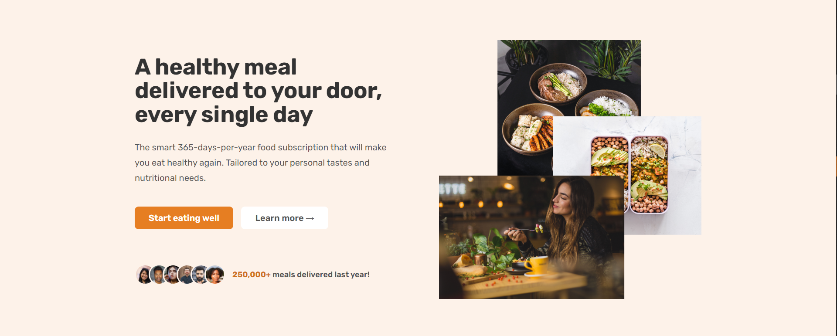

* Plan out the different design ingredients for the page
  + Typography, Colors, images, Icons, Shadows, Border-radius, Whitespace/Layout
* Have a parent container to do the equal splitting and the child elements to do width: 100%
  + Eg. *.parent { display: grid; grid-template-cols: 1fr 1fr; } .child { width: 100% }*
* Adding borders inside the element can be done via *box-shadow* property
  + Eg. *box-shadow: inset 0 0 0 3px #fff;*
* Having utility CSS classes to inject margins to elements
  + Eg. *.margin-right.sm { margin-right: 1.6rem !important; }*
* To translate flex items towards 1 direction, can apply negative margins
  + Negative gaps does not work in flex-box

### Notes for Header and Navigation



* When creating a button, we must **use different elements based on what the button does**
  + **Directs** user to another page: ***<a>***
  + Perform an **action** within the page: ***<button>***
* For the navigable links in the navigation bar, we can place the links into an *<ul>*

### Notes for How It Works section

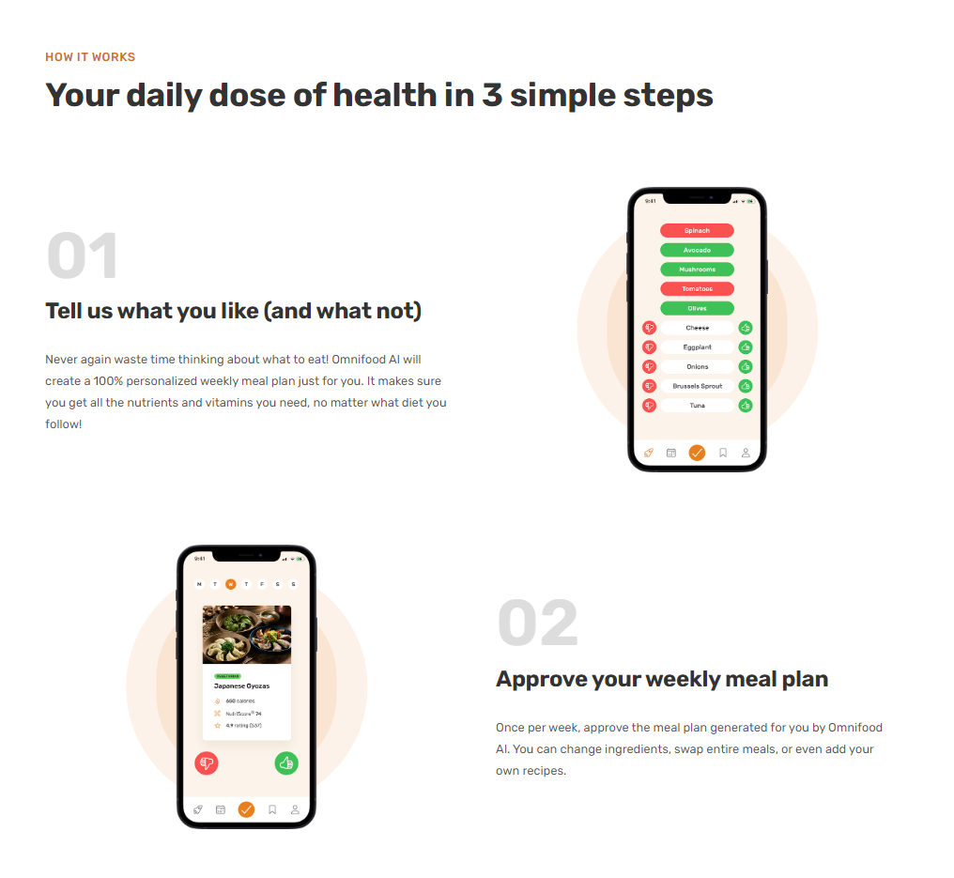

* *gap* property in grid can be split into ***row-gap*** and ***­column­-gap*** for better customization
* To **let heading stand out from its content**, there should be **significant margin between them**
* **Rules** (eg. contrast ratio rule) **can sometimes be broken** in situations such as for less important elements or to achieve better visuals etc

### Notes for Featured In section



* **Overlaying grey on images**
  + ***filter: brightness(0)*** 🡪 turning the image into black
  + ***opacity: 0.5*** 🡪 turning the image to grey
* **Headers for a set of content can still be *<hX>* even if the sizing does not match** that header element
  + Eg. “AS FEATURED IN” is a *<h2>* even though the sizing is totally not matching
* For each *<img>*, we should **give meaningful *alt* such that text-to-speech reader can give effective description** of the image

### Notes for Meals section

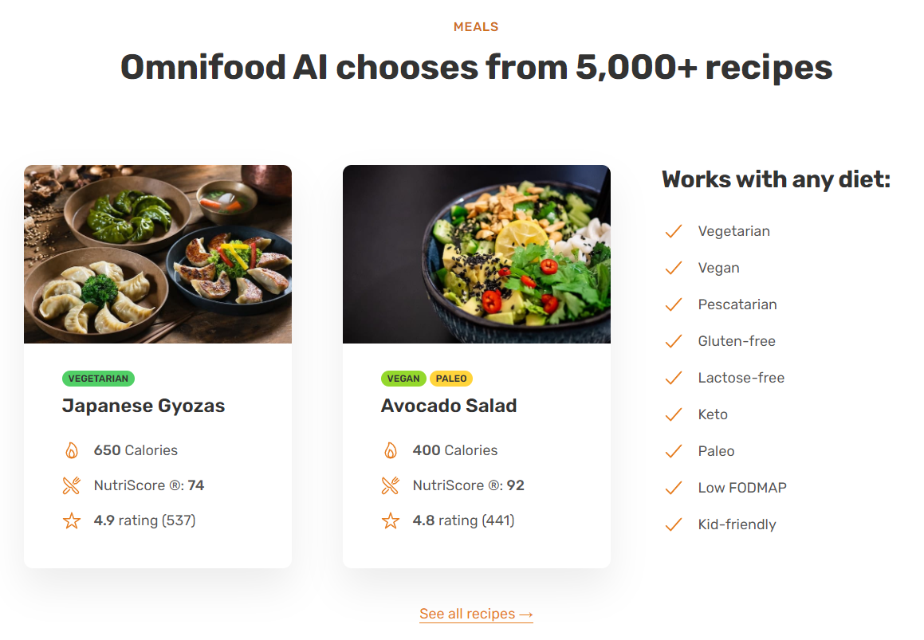

* Amount of **border radius scales with the size of the element** when trying to circle-fy the element
* When there is content overflowing from a circle-fy element, we can set ***overflow: hidden***to **prevent any overflowing** and **maintain the circular look**
* When using an icon pack, the **modification of icon color** may need to be done through ***color***, ***font-color***, ***fill***, or ***stroke*** property
* When **adding an underline to a link**, use ***border*** instead of *text-decoration* as it provides better visuals
  + Can use ***currentColor*** keyword to directly use current font color

### Notes for Testimonials section

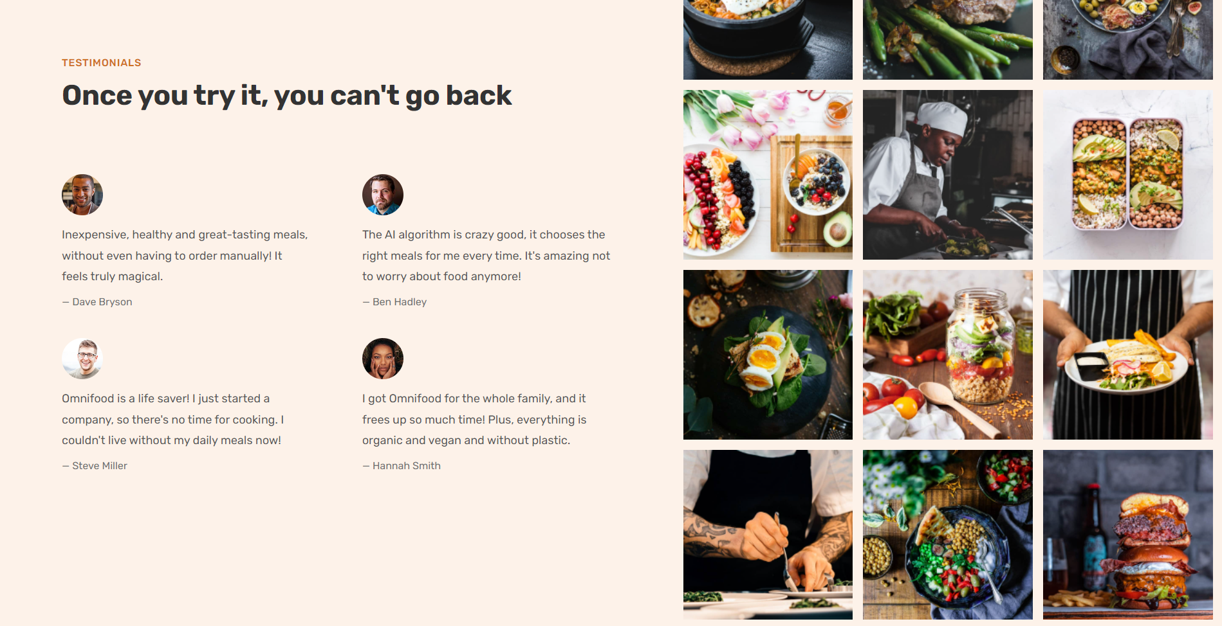

* A **different background color** is used to **garner user’s attention**
* ***fr* can be used like % to better define the sizing differences** in rows/columns of CSS grid
  + eg. *grid-template-columns: 55f 45fr;*
* Sometimes, we **can use fixed width on an image to keep it small throughout** different screen sizes
* ***line-height*’s unit is a multiplier** (eg. *line-height: 1.8* means 1.8x)
* Can change to ***display: block*** to **remove the line spacing between <img>** due to them being inline elements
* Can combine ***overflow: hidden* and *transform: scale(…)***to **provide a zoom-in effec**t upon hovering an image

### Notes for Pricing and Features section

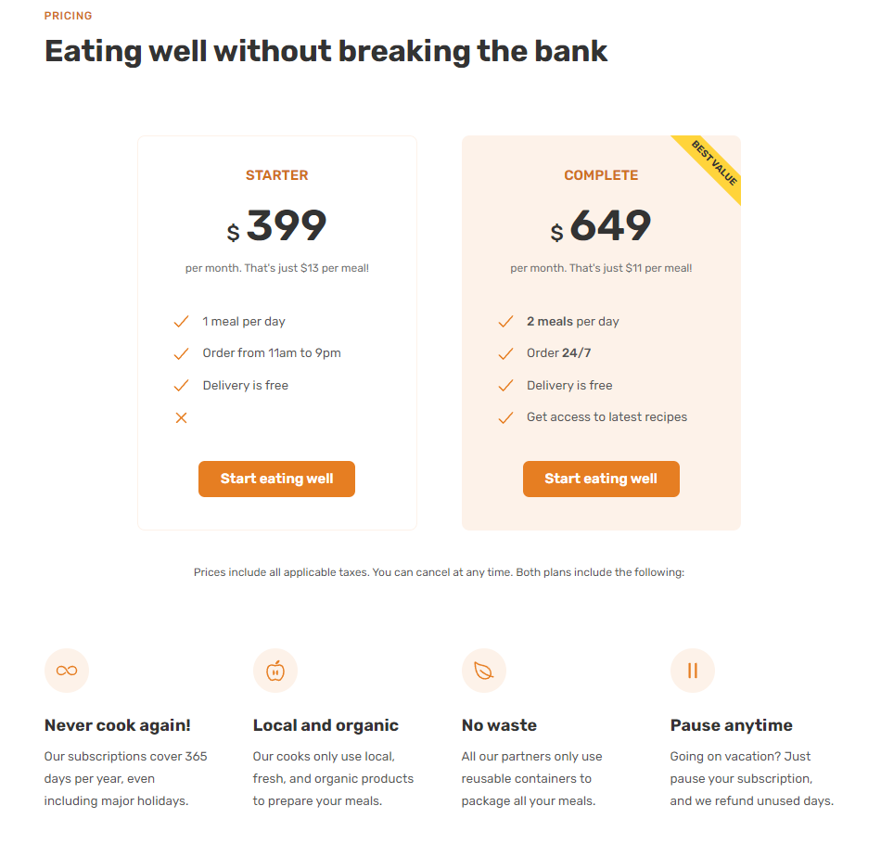

* To **align a button created using *<a****>*, we can simply use ***text-align***
* A **circle background can be added** to the icon by adding **padding**, **setting a background color** and **circle-fying it**
  + *background-color: XXX; | padding: XXX | border-radius: XX;*
* Can **wrap text content with another element** (eg. *<span>$</span>*) to give a **different styling**
* A **“ribbon”** can be added to an element by using **pseudo element** (Eg. Making a “best value” ribbon by using *::after*)
* **Don’t give any ambiguous spacing to an element** which may lead to user does not know which section the element beings to
  + Eg. “Prices include all applicable…” should belong more to the price plans section
* **Giving elements different background color**s to indicate **which element user should pay attention to**

### Notes for CTA section

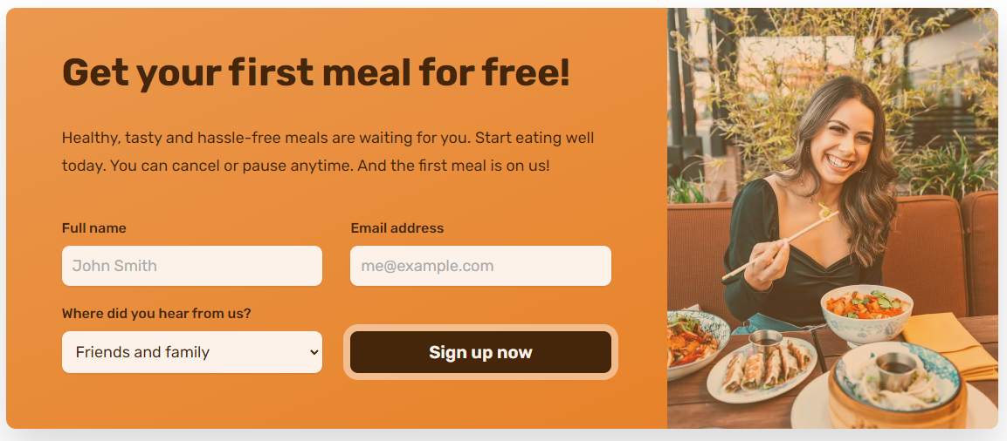

* The **direction of a linear gradient** can be set via **degrees** or **directions**
  + Eg. *background-image: linear-gradient(to right bottom, black, white);*
* If we need **to overlay a color/gradient over the background image**, we should **use CSS** to set the background image for an element instead of just using *<img>*
  + Eg. *background-image: linear-gradient(to right bottom, black, white), url(eating.jpg);*
* **Certain CSS properties** like *font-family* and *color* **does not get inherited into input elements**, we **must explicitly inherit** it
  + Eg. *font-family: inherit; | color: inherit;*
* In *<form>,* we **can specify the URL that we submit the form to via the *action* attribute**
  + Eg. *<form class=”XXX" action=”#”>*
* **For any *<input>*, we can pair it with a *<label>*** by using the ***for*** attribute in *<label>* and ***id*** in *<input>*
  + Allow us to perform action like clicking label to focus on the input

### Notes for Footer section

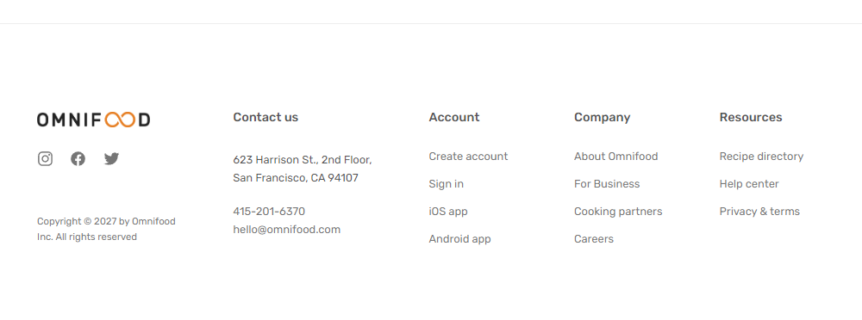

* **Content in a footer gets repeated** across pages, so it **should be in an element such as *<footer****>* instead of *<main>*
* A **list of links** should be written in a list element (Eg. ***<ul>*)**
* To **better distinguish footer** from the other sections, we can **add a faint line** above
* [TRICK] Can **allocate the remaining space to a flex containe**r **to push content** to a certain direction by **auto-ing margins**
  + Eg. margin-top: auto to push content to the bottom of the container
* **Use tints and shades to establish visual hierarchy** within the footer section

# Section 8 – Omnifood Project – Responsive Web Design

## Media Queries

A CSS syntax that allows us to **conditionally modify the site’s styling depending on the device’s general type** (media type**) or its specific characteristics** (media features)

* Media types: all, print, screen
* Media features: min-width, max-width, aspect-ratio, min-height, max-height etc

### Max-width

The general process is:

1. We **have a set of global CSS** that applies across all viewport sizes
2. **For different breakpoints** of the viewport’s sizing, we **overwrite specific parts** of global CSS by using media queries

Note. **Ordering of media queries matters** as it **determines which overwriting will be used** when the viewport’s width falls under 2 or more media queries

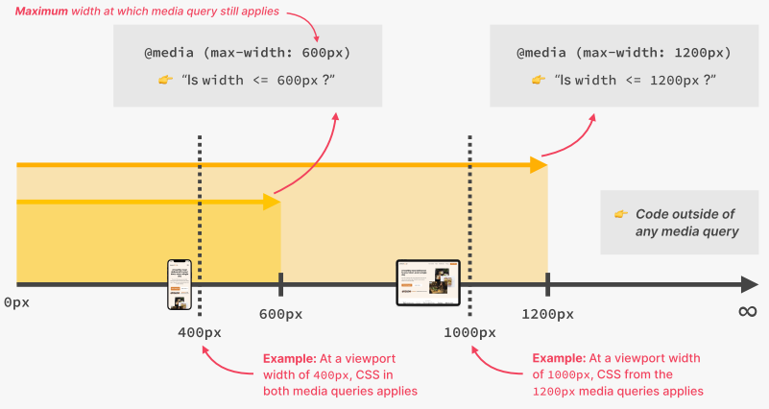

### Units to use

Always use *em* when specifying units in the condition of a media query

* Pixels cannot be used as it does not adjust to browser’s font size setting and user’s zoom level
* *rem* can have bugs when used in media queries, avoid it to be safe

**NOTE. We still use *rem* in CSS rules and maintain the 1*rem* to 10*px* scaling**

#### rem and em

*rem* 🡪 Root font size | *em* 🡪 Current font size

They DO NOT depend on the font size stated in HTML when performing media queries

* So, 1*rem* =/= 10px. Instead, 1­*rem* = 1*em* = 16*px*

## Breakpoints

The **pixel values** we specify in media queries to indicate **which viewport width we want our design to change**

### Selecting breakpoints

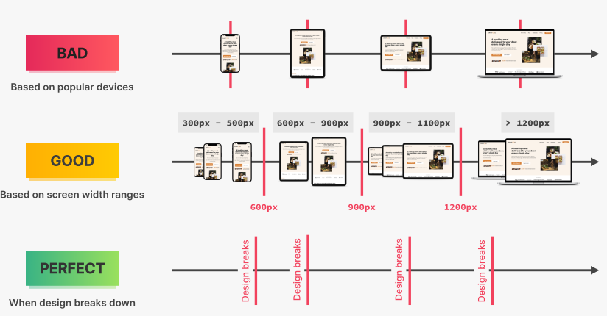

(1) **Bad approach**: Selecting breakpoints based on **specific popular devices**

* **Not maintainable** as popular devices can easily change in the future

(2) **Good approach**: Selecting breakpoints based on **specific screen width ranges** for different devices

* Can be **hard to determine and separate** effectively

(3) **Ideal approach**: Selecting breakpoints based on **whenever the design breaks** (ie. Not acceptable)

* **Cannot really do it without thinking about devices**

**Approach to use: Mixing (2) and (3) together**

* Start with a large screen, keep decreasing screen’s size to identify when the design breaks
* Determine breakpoints by balancing the width where the design breaks and the widely used screen widths
  + In each breakpoint, we fix the broken elements or make it more fit to the new width (eg. too large/small for the new width)

**Note. Each breakpoint should support around 300px change in width**

## Notes for small desktops (below around 1300px to 1366px)

* Breakpoint is 1344px, **a compromise between where the design breaks** (1300px) **and a widely used screen width** (1366px)
* **Keep the # of lines in text content minimal** for better **readability** and **maintain the intended design**
  + Can decrease font size if required

## Notes for landscape tablets (below 1200px)

* When everything seems to be too large for the current viewport, **adjust their sizes by directly changing the root font size**
  + ie. *html { font-size: XX% }*
* **Spacing** between sections or components **can be too wide or narrow in the new viewport**, adjust them accordingly
  + Adjust padding/margins

## Notes for portrait tablets (below 944px)

* Current **grid layout can become unfeasible as the viewport width narrows**, update the layout accordingly
  + eg. Add/Remove columns in grid
* ***<img>*** is an inline element, so it **gets affected by *text-align***
  + Allow us to center *<img>* with *text-align: center*
* Viewport width can become **too small to display the full navigation bar** without affecting other elements, **replace it with a mobile version** instead
  + Click on button to toggle an overlay that consists of those navigation links
* If an element needs to be **“transition” in from an invisible state**, we **cannot use *display: none***
  + *transition* does not work with *display: none*
  + Instead, we **use *opacity: 0*, *pointer-events: none*, and *visibility: hidden***to hide the element visually, from mouse and keyboard, and from screen reader
  + Toggling of hiding via CSS can be done by adding and removing CSS class es
* In a CSS **selector**, we **can consider the element’s attribute value** as well
  + eg. *.icon-mobile-nav[name=”close-outline”] {…}*

## Notes for smaller tablets (below 704px)

* **Elements**’ sizes specified in earlier viewport may result in them **being too cramped in current viewport**, **adjust those size accordingly**
* **Re-arranging the layout of an entire section may be needed** to better fit the viewport
* A **grid item can be specified to be on a certain row or takes up a certain # of cells**
  + *grid-row: ROW_TO_BE_ON*
  + *grid-column: span HOW_MANY_CELLS*

## Notes for phones (below 544px)

* Remember to **keep the buttons clickable through the different viewport** sizes
  + Adjust the height and widths
* **Resolve any ambiguous spacing** between components or sections

# Section 9 – Omnifood project – Effects, Optimizations, Deployment

## Effects

### Anchoring

To have a link element to scroll to a specific section of the page, we need the following:

1. The container element for that section has an *id* field
   1. Eg. <div class=”section-cta” id=”cta>XXX</div>
2. The link element has a *href* field that points to that container
   1. Eg. *<a href=”#cta”>XXX</a>*

User can just click the *<a>* to go to that section

**Note. Instead of scrolling to that section, we can perform other actions to that section by intercepting the click event**

### Smooth scrolling

Anchoring can only provide an instant transition, instead of smooth transition over time. To do that, we must use functions such as:

1. Scroll by pixels 🡪 *window.scrollTo({top: XX, behavior: “smooth”})*
2. Scroll to an element 🡪 *targetEl.scrollIntoView({behavior: “smooth”})*
   1. The *targetEl* is identified by query-selecting the *href* attribute in *<a>*

## Test and optimize

### Browser support

Certain **CSS** **properties can be experimental and not supported** on all browsers. We can check them on <https://caniuse.com/>

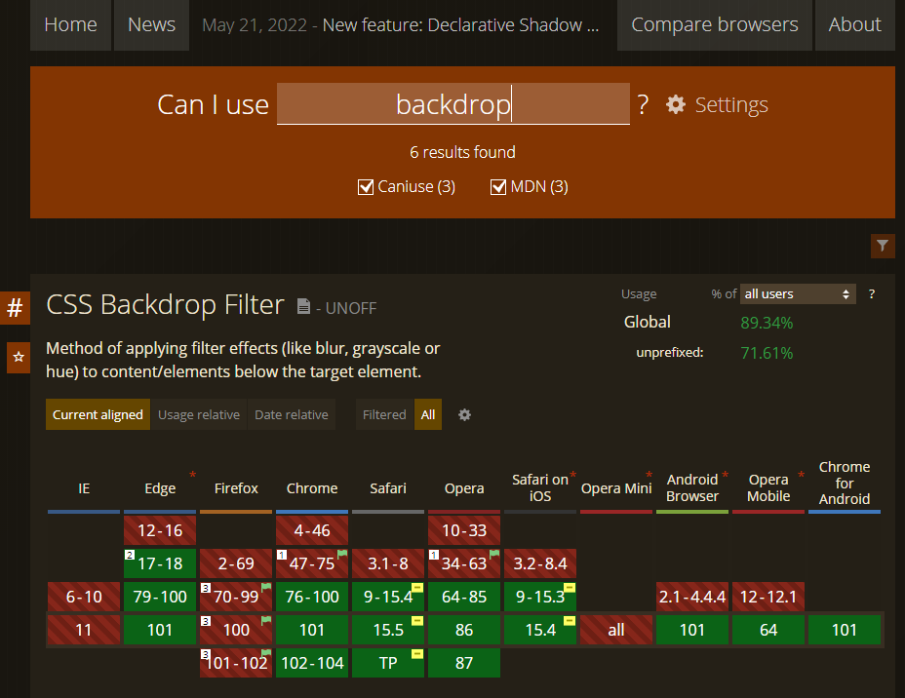

* Some properties **can be partially supported** (eg. *backdrop-filter*) by the browsers through **adding vendor prefix** to the properties
  + Eg. *-webkit-backdrop-filter, -ms-backdrop-filter* etc
* Some properties are **totally not supported** (eg. *gap* in flexboxes of Safari), we can either
  + Use them in supported browser but **keep the difference between using/not using to be minimal**
  + Use them in supported browser and **mimic it** using existing properties in existing browsers (eg. Insert *margin* instead of using *gap*)

## Testing website’s quality and performance with Google Lighthouse

An **automated tool in Chrome dev tools** to **verify the quality and performance of websites**. It helps to check the following:

1. **Performance**
   1. Must be tested on the deployed websites, instead of locally
2. **Accessibility**
3. **Best** **Practices**
4. **Search Engine Optimization (SEO)**

Note. The scoring may not be fully indicative of IRL experience of the website. We can ignore some issues suggested by Lighthouse in certain cases

## Adding meta description and favicons

### <meta>

A **HTML element** that **represents metadata (data that give info about other data**) that cannot be represented by other HTML meta-related elements. There are **4 types of metadata**:

1. With *name* attribute:
   1. **Document-level metadata** that applies to the whole page
   2. Eg. *description*, *viewport*
2. With *http-equiv* attribute:
   1. **Information equivalent to what can be given by a similarly named HTTP header**
3. With *charset* attribute:
   1. **Declaration on which character encoding** that the document is encoded in
4. With *itemprop* attribute:
   1. **User-defined meta data**

* Specifies aspects of the page (eg. viewport size, page’s description, and character encoding)

### Favicons

**Icons that will be displayed to represent the website** on various platforms and we need to size them accordingly

* Browsers
  + Size: 64x64
  + Eg. *<link rel="icon" href="img/favicon.png" />*
* Apple home screen:
  + Size: 180x180
  + Eg. *<link rel="apple-touch-icon" href="img/apple-touch-icon.png" />*
* Android home screen:
  + Size: 192x192 and 512x512
  + Must be accompanied by a *manifest.webmanifest* file that indicates the icon’s source, type and size

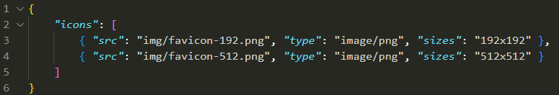

* + Eg. *<link rel="manifest" href="manifest.webmanifest" />*

## Optimizing images

To reduce the loading time for the page, we must optimize the dimension and size of the images using tools or websites like <https://squoosh.app/>

### Dimension

1. During development, use the highest dimension that you can find
2. During optimization, identify what is the highest dimension that the image will be rendered at (eg. 200px width)
3. Resize the source image to be 2x that dimension
   1. Some screen use 2 pixel to render 1 pixel

### Size

Images should be kept around the KBs, and this can be done by sacrificing quality and image format

### <picture>, <source>, and <img>

In some browsers, certain image formats are not supported within *<img>*. As such, we must use *<picture>* where we can declare multiple images through *<source>* and an appropriate image will be used in *<img>*

**Example:**

